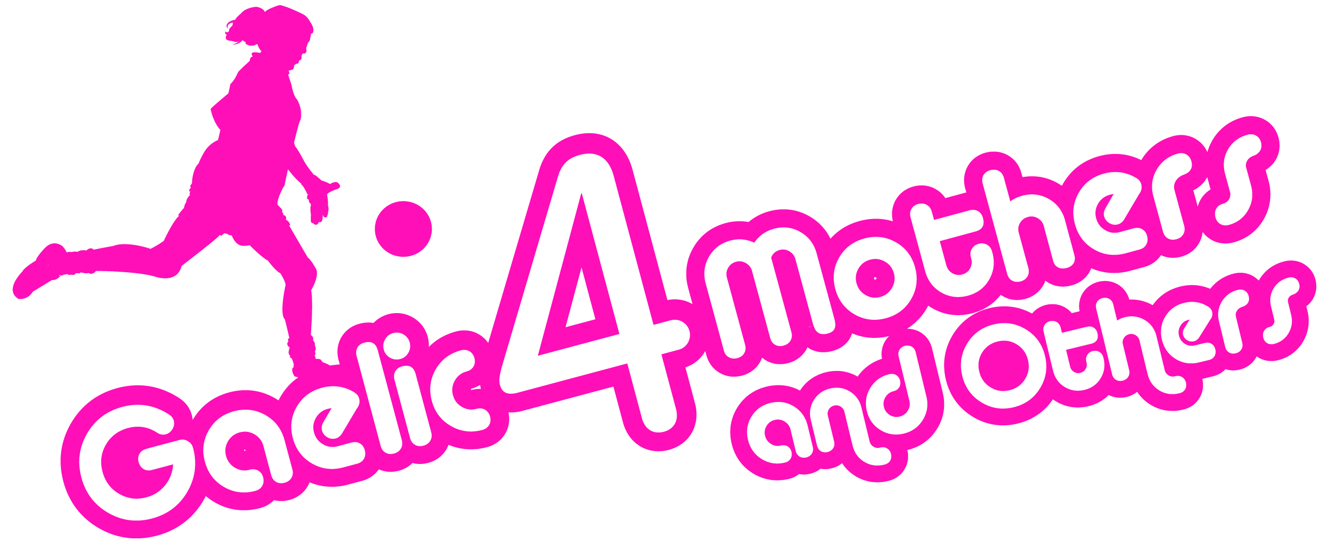
2017 Gaelic4Mothers & Others
ETHOS FORM
CLUB NAME: ___________________________________
COUNTY: ___________________________________
G4M&O CONTACT NAME: ___________________________________
G4M&O CONTACT PHONE NUMBER: ___________________________________
G4M&O CONTACT EMAIL ADDRESS: ___________________________________
DATE G4M&O SITE COMMENCING IN 2017 ___________________________________

G4M&O Programme Ethos:
All Gaelic4Mothers&Others sites should familiarise themselves with the G4M&O programme ethos. All sites should read below and agree to abide by these terms at all times.
- G4M&O is a non-competitive recreational form of Ladies Gaelic Football
- G4M&O is all inclusive. It should always welcome women over the age of 21 and who currently do not play any form of competitive club football and would like to play. They cannot be a registered player with any LGFA club
- All G4M&O training sessions are fun orientated with the focus on learning the skills of our game, developing social skills and providing an opportunity for women to be physically active
- All G4M&O blitzes are about participation and not winning. There are no winners or losers at G4M&O Blitzes and no scores are recorded. Blitzes should aim to allow women to meet other G4M&O Sites while having fun playing small sided matches
- All G4M&O Clubs must seek prior approval from the National Development Officer prior to hosting G4M&O Blitzes
Does your club agree to abide by the LGFA G4M&O ethos as outlined above?
Yes No
Co-ordinator Signature: ____________________ Date: ___________________
Coach 1 Signature: ____________________ Date: ___________________
Coach 2 Signature: ____________________ Date: ___________________
To be returned to:
Paula Prunty,Ladies Gaelic Football Association, Croke Park, Dublin 3
Or paula@ladiesgaelic.ie

