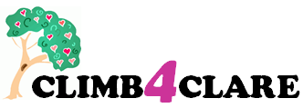
PLEASE SUPPORT

Children’s Lives Include Moments of Bravery

Help us to bring the CLIMB® Programme to your Area!

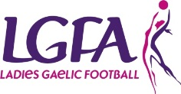
About CLIMB:
CLIMB® is a programme for children aged 5-12 who are experiencing the impact of a parent’s, other significant adult’s or a brother or sister's cancer diagnosis. Throughout the programme the children will develop an understanding of cancer and from this understanding the myths and fears that children can hold about cancer will be dispelled. We could all be affected!
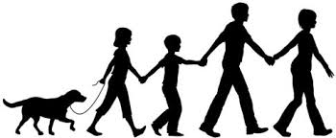
Join Our Family 1km Walk/Run
CLIMB TO THE FINISH LINE

Venue: Na Fianna GAA Club
Your Club Crest
Date: Saturday 20th September
Time: 11.30 a.m.
Donations on the Day

Bring all the family!!

