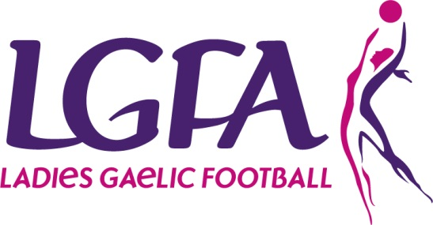
2017 Interfirms Blitz
ENTRY FORM

Please complete Entry form and return with appropriate Entry Fee to Paula Prunty, National Development Manager by 14th June 2017 via Post (LGFA, Croke Park, Dublin 3) or email paula.prunty@lgfa.ie

Please Note – All sections must be completed
Company Name: _____________________________________________________
County: ________ ____________________________________________
Team Contact Name: _____________________________________________________
Phone: (Mobile): ___________________________________________
Email: _______________________________________________
Jersey Colours: _______________________________________________
Total Number of Teams entering: ___________
Total Number of Players: ____________ (12 players maximum per Team)
Payment Details
Payment Type: Cash ________ Cheque ________ Credit Card ________ Postal Order ________
(Please ensure all Cheques/Postal Orders are made payable to the LGFA)
Credit Card Details
Card Type _______________________Name on Card _______________________________________
Card Number __________________________________
Expiry Date ________________ Security Code (last 3 digits on back of card) _________
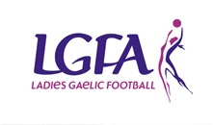
Total Payment Amount: ______________________

