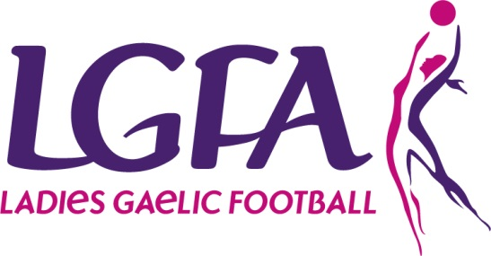
2018 Interfirms Blitz
ENTRY FORM

Please complete Entry form and return with appropriate Entry Fee to Aisling Doonan, National Development Officer by 27th April 2018 via Post (LGFA, Croke Park, Dublin 3) or email aisling.doonan@lgfa.ie

Please Note – All sections must be completed
Please tick blitz entering: Competition Recreational

Company Name: _____________________________________________________
County: ________ ____________________________________________
Team Contact Name: _____________________________________________________
Phone: (Mobile): ___________________________________________
Email: _______________________________________________
Jersey Colours: _______________________________________________
(7aside/max panel 12) | Competition | Recreational | Total No. of Teams entering | Total Cost Due
No of teams Entering |  |  | @ 60euro per team | =
Total Number of players
Payment Details
Payment Type: | Cash | Cheque | Credit Card | Postal Order
(Please ensure all Cheques/Postal Orders are made payable to the LGFA)
Credit Card Details:

Card Type ___________________ Name on Card _______________________________________

Card Number__________________________________
Expiry Date: (month/year)_____/____ | Security Code (last 3 digits on back of card) _________
