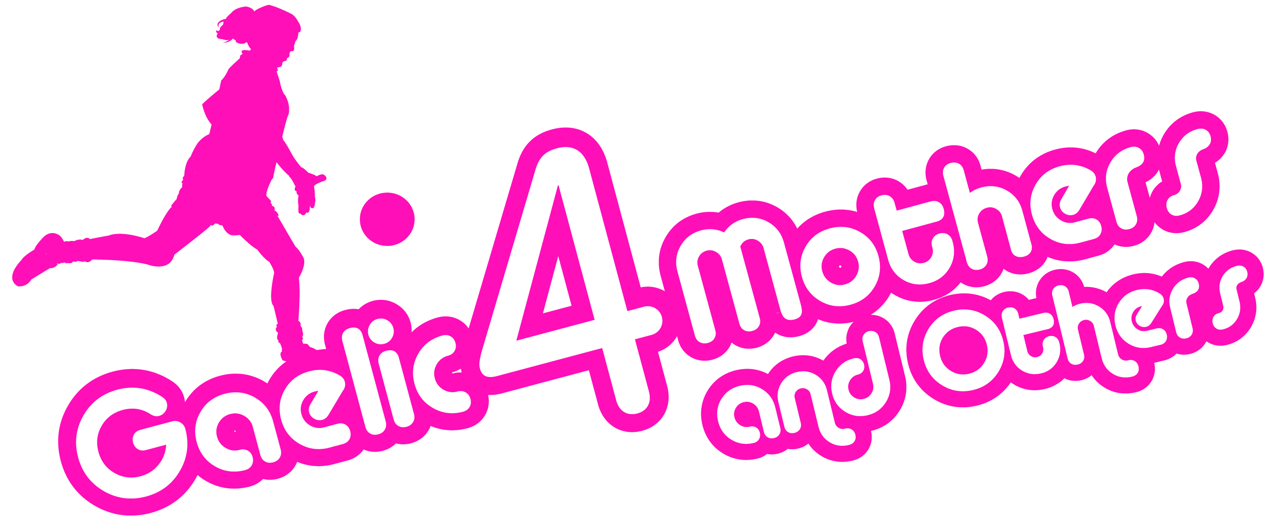
2018 Gaelic4Mothers & Others
ETHOS FORM
CLUB NAME: ___________________________________
COUNTY: ___________________________________
G4M&O CONTACT NAME: ___________________________________
G4M&O CONTACT PHONE NUMBER: ___________________________________
G4M&O CONTACT EMAIL ADDRESS: ___________________________________
DATE G4M&O SITE COMMENCING IN 2018 ___________________________________

G4M&O Programme Ethos:
All Gaelic4Mothers&Others sites should familiarise themselves with the G4M&O programme ethos. All sites should read below and agree to abide by these terms at all times.
- G4M&O is a non-competitive recreational form of Ladies Gaelic Football

- G4M&O is all inclusive. It should always welcome women over the age of 21 and who currently do not play any form of competitive club football and would like to play. They cannot be a registered player with any LGFA club

- All G4M&O training sessions are fun orientated with the focus on learning the skills of our game, developing social skills and providing an opportunity for women to be physically active

- All G4M&O blitzes are about participation and not winning. There are no winners or losers at G4M&O Blitzes and no scores are recorded. Blitzes should aim to allow women to meet other G4M&O Sites while having fun playing small sided matches

- All G4M&O Clubs must seek prior approval from the National Development Officer prior to hosting G4M&O Blitzes and challenge games.

Does your club agree to abide by the LGFA G4M&O ethos as outlined above?
Yes No

**Please complete page 2
General Data Protection Regulation Guidelines (Page 2/2)

- I understand the personal data on this form (“Personal Data”) will be used by the Club, Province and the LGFA for the contractual purpose of registering (or re-registering) our Gaelic4Mothers&Others club.

- I understand that the Personal Data will be retained by the Club, Province and the LGFA for such period as our Gaelic4Mothers&Others club subsists.

- I understand that I can resign my role as co-ordinator by writing to the Club, Province or the LGFA and my Personal Data will then be erased.

- I understand that my Personal Data will also be used for administrative purposes in relation to Gaelic4Mothers&Others.

- I understand that if I do not provide my Personal Data the membership of our Gaelic4Mothers&Others club cannot be registered with the Province and the LGFA.

G4M&O Contact Signature: ________________________ Date:_________________

Print Name: __________________________________________

Other Signatures Required for Ethos

Coach 1 Signature: ____________________ Date: ___________________

Coach 2 Signature: ____________________ Date: ___________________

To be returned to:
aisling.doonan@lgfa.ie Or Ladies Gaelic Football Association, Croke Park, Dublin 3

