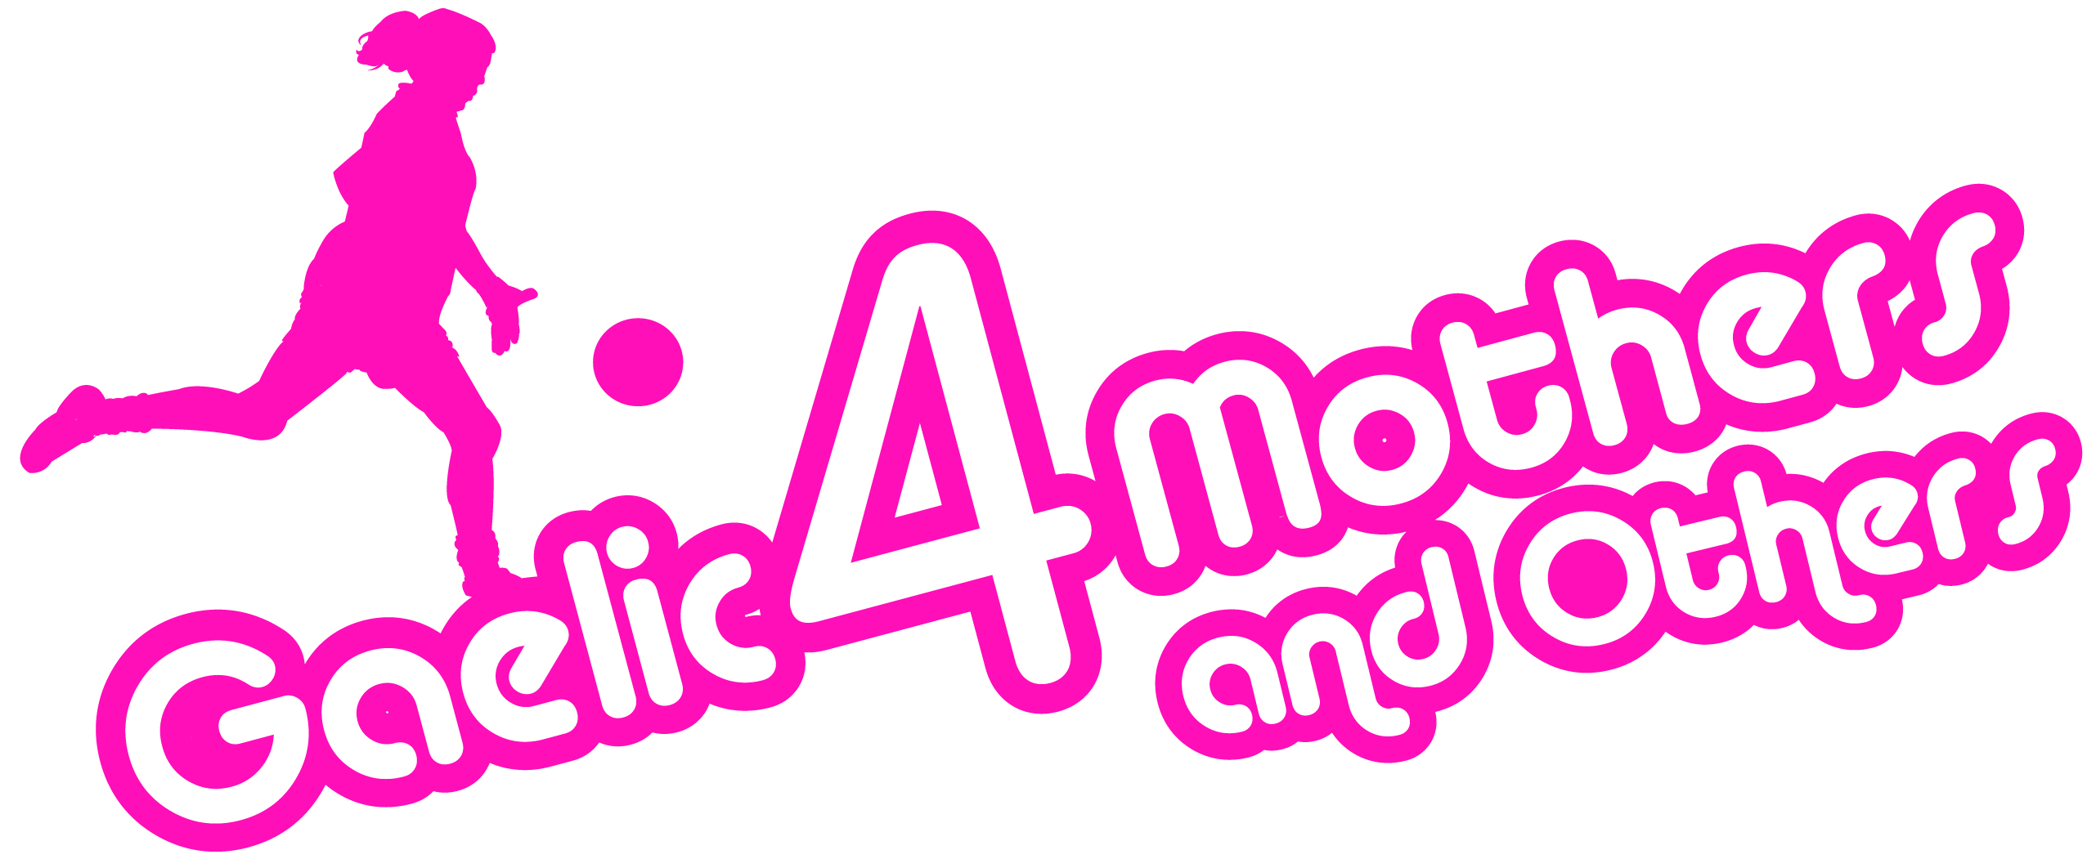
2018 Gaelic4Mothers&Others
NATIONAL BLITZ ENTRY FORM

Please complete Entry form and return with €200 entry fee to Aisling Doonan, National Development Officer by 7th September 2018 via Post (LGFA, Croke Park, Dublin 3) or email aisling.doonan@lgfa.ie

ONLY One entry per club

Please Note – All sections must be completed
Club Name: _____________________________________________________
County: ________ ____________________________________________
Team Contact Name: _____________________________________________________
Phone: (Mobile): ___________________________________________
Email: _______________________________________________
Club Colours: _______________________________________________
Number of years Club is running G4M&O Initiative ________________________
Total Number of Players:________ (20 players maximum per Team)

All players must be registered members with the LGFA – checks will be carried out prior to the blitz
Payment Details
Payment Type: Cash ________ Cheque ________ Credit Card ________ Postal Order ________
(Please ensure all Cheques/Postal Orders are made payable to the LGFA)
Credit Card Details
Card Type _______________________Name on Card _______________________________________
Card Number __________________________________
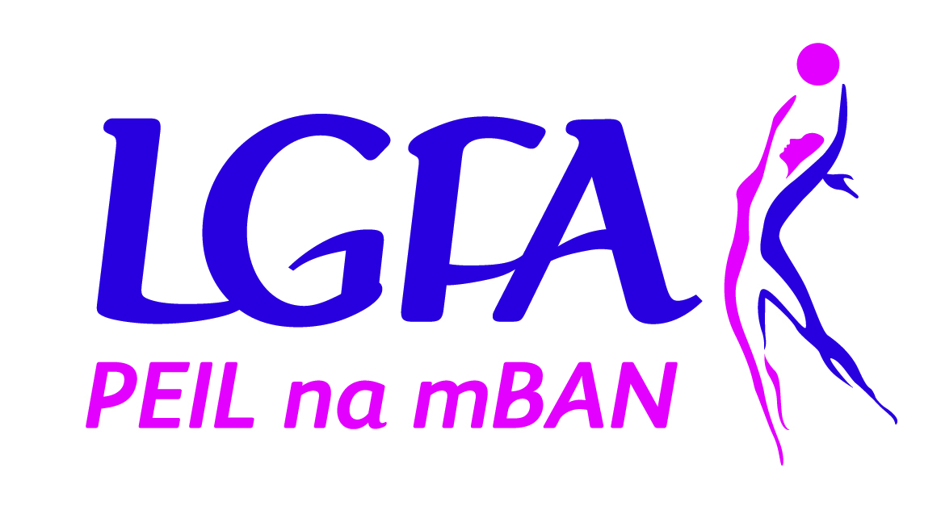
Expiry Date ________________
Security Code (last 3 digits on back of card) _________
Total Payment Amount: ______________________
Privacy Notice
The following Privacy Information is being provided to you as outlined in the General Data Protection Regulation. It is intended to inform you of how the Personal Information provided on this form will be used, by whom and for what purposes.
The LGFA processes personal information to administer and conduct LGFA related activities. We will never share your information with third parties for any purpose without your consent.
Purpose of processing your personal data?
The purpose of your personal data is to enter team to the National Gaelic4Mothers&Others Blitz Day and process payment.

How long will my details be held?
Your details will be held for the sole purpose of the event, once payment is received. Your payment details will be deleted. Your personal details will be deleted upon completion of the blitz.
Contact Details
If you require any information regarding Data Protection and how your data is processed by the LGFA, please contact the LGFA’s Data Protection Officer
Tel: 01 8363156 or
Email: dataprotection@lgfa.ie
Post: Data Protection Officer, LGFA, Croke Park, Jones Road, Dublin 3.

