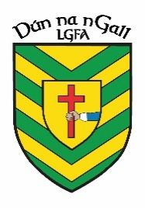
NEWS RELEASE
FOR IMMEDIATE RELEASE
Donegal LGFA
04/05/23

Donegal LGFA and Yes Chef Catering Announce Sponsorship of County Minor Team Jersey
Donegal LGFA and Rite Financial Solutions Announce Sponsorship of County Minor Team Training Gear

Donegal LGFA
Donegal LGFA is delighted to announce a partnership with Yes Chef Catering and Rite Financial Solutions in relation to sponsorship of our County Minor Panel.
It is great to have Yes Chef Catering and Rite Financial Solutions onboard and we look forward to seeing these partnerships flourish in the future.

Yes Chef Catering

Yes Chef Catering is a local business in the north west run my Michael and Tara and their team. They can cater for the likes of birthday parties, weddings, corporate events, communions, etc., to name a few. Their professionally trained chefs make life easier for their customers by working closely toa budget, menu requirements and timeline.

www.yeschefcatering.ie

Rite Financial Solutions

Rite Financial Solutions is run my Annemarie McGeehan in Ballybofey. They can offer advice ono an extensive range of pensions, investments, savings, and life assurance.

www.ritefinancial.com

