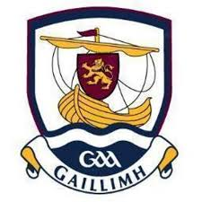

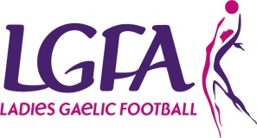
Galway Ladies Gaelic Football Association
Inter County Management Application Form

Position Applied For
U16 County Manager

- Personal Details
Name:
Address:
Email:
Phone:
Mobile:
Club:

- Code of Ethics & Good Practice for Young Players
Garda Vetting:
Please attach a copy of your Garda Vetting Certificate to application, if you have not yet applied to be Garda vetted please download a form from www.ladiesgaelic.ie and forward onto Paula Prunty, Croke Park, Dublin 3 ASAP

- Coaching qualifications (Please tick relevant box):
LGFA FUNdamentals Coaching Course |  |  |  | LGFA Level 1 Coaching Course
Yes |  | No |  | Yes |  | No
Date: |  |  |  | Date:
Please list the name of other coaching courses you have completed which is relevant to your application:

- Management Experience:
List previous managerial roles / experience (applicable to club / county):
- Playing Experience
List previous playing experience (applicable to club / county):

- Proposed Management Team:
(Applicants must specify their full management team prior to interview stage)
Position | Name | Club | Garda Vetted
 |  |  | Yes | No
Team Selector
Team Selector
Female Liaison Officer
Team Administrator
Medic / First Aid / Physio
Fitness Coach
Other (state role)
- References:
Please supply the name, address and contact details of two people whom the Galway LGFA can contact that from their personal knowledge are willing to endorse your application.
Referee (1): | Referee (2):
Name: | Name:
Address: | Address:
Address: | Address:
Email: | Email:
Number: | Number:
Position: | Position:
- General Information:
a) Do you agree to abide by the guidelines of Code of Ethics & Good Practice for Young Children | Yes | No
b) Do you agree to abide by the rules of the Ladies Gaelic Football Association and the (Insert County) Ladies Gaelic Football Association? | Yes | No
c) Do you agree to abide by the Galway Code of Best Practice for Inter County Management | Yes | No
- Please indicate any other relevant criteria you have that you deem to be of extra benefit to
Galway Ladies Football and in particular to your selection as manager.
List any additional qualifications, skills or experiences that may be relevant to position applied for & attach certificates of qualifications:

- Budget
Please provide a draft annual budget as to the expected running costs of your team (costs should include expectations for professional services e.g. physio, strength & conditioning, professional services, team building, expenses). Note – transport, gear and equipment will be provided by Galway LGFA for all teams.

- Signature: ________________________________ Date: / / /
Application and relevant documentation must be returned to County Secretary no later than
5pm November 13th 2019. Post to Geraldine Heverin, Ballyedmond, Clonberne, Co. Galway. H53E036 or email: secretary.galway@lgfa.ie

