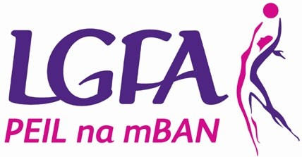
LADIES GAELIC FOOTBALL ASSOCIATION
EXCITING JOB OPPORTUNITY – JOIN THE TEAM

National Fixtures Administrator

Founded in 1974, Ladies Gaelic Football is one of the fastest growing sports in Europe with over 190,000 registered members. With over 1,200 clubs in Ireland and membership growing by the day, Ladies Gaelic is reaching women and girls from all over the country.

The Ladies Gaelic Football Association provides a social outlet and a healthy activity for thousands of people around the world. Starting with club football for primary school girls, an individual can keep playing Ladies Gaelic for as long as she wants, especially with our Gaelic4Mothers&Others initiative for those adults interested in recreational or non-competitive participation.

The Ladies Gaelic Football Association strives to be a modern, innovative and well-run organisation that provides a quality service and support system for all members, from an 8 year old girl kicking her first ball in her local club to an elite athlete scoring her first point in Croke Park.

To continue its development as one of the largest, fastest growing, active and dynamic sports in Europe the Association is looking to fill the position of National Fixtures Administrator, based in LGFA Head office in Dublin. (FULL TIME POSITION)

Reporting to the National Operations & Planning Manager you will be responsible for:
- The management of all aspects of the annual national fixtures plan.
- Providing support on the administration of any necessary PR elements relating to national fixtures and arrangements for match broadcasting.
- Act as event pitch side co-ordinator for key national fixtures as required.
- Act as a secondary CODA Officer and implement the CODA rules procedures as required
- Servicing the National Fixtures Committee by providing secretarial and administrative support Successful candidates will have:
- Minimum 3 years’ experience in an administrative role in a service-related industry or sports related background dealing with members, volunteers or members of the public where excellent relationship management is the key to success
- Must be highly competent on the range of Microsoft software packages and pay great attention to detail.
- Must have excellent interpersonal skills and be a strong team player.
- Strong planning and organising skills with excellent attention to detail.

- Good interpersonal skills with the ability to build effective internal and external relationships with a variety of people.
- Ideally have a knowledge or interest in the sport.

If you think this is for you and you meet our criteria, please submit a completed application form for this position to:
Paula Prunty
Operations & Planning Manager Ladies Gaelic Football Association, Croke Park,
Dublin 3.
Email: paula.prunty@lgfa.ie

Completed application forms must be received by the Association not later than 4.00pm on Friday 14th April 2023. Late applications will not be accepted.

