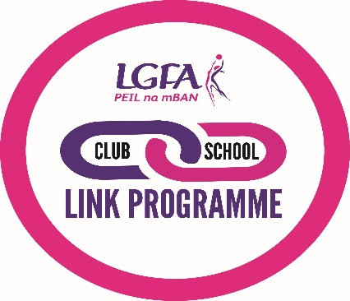
LGFA Club-School Link Application for Recognition
This is the Formal Application of Recognition for the delivery of the LGFA Club-School Link programme in our community.

Year of Application
Club Name
School Name
County

We are seeking recognition for the delivery of the programme at level:
(Please Place an X beside your desired award)

Bronze |  | Silver |  | Gold

Our Delivery Team

 | Club Delivery Team | School Delivery Team
Club/School Link Coordinator Name
Club/School Link Coordinator Contact Email
Please list any other club and/or school personnel involved in the delivery of the programme
Name
Role
Name
Role
Name
Role
Name
Role

Please provide brief details on all communications between the club and the school throughout the year:

Provide details on how your Club-School Link has met minimum requirements to receive recognition applied for
Club Requirements

School Requirements

Please provide details of regular or irregular coaching opportunities on the school site provided by club coaches (Only Applicable to Silver or Gold Award Applications)

Please list any additional agreed actions to delivered as part of the Club – School Link Programme
Club

School

Please provide full details of your review at the end of agreed period of the activity including monitoring and evaluation

We hereby declare that the information provided is true and correct. We also understand that any willful dishonesty may render this application to be refused.

Club Signature |  | School Signature
Date |  | Date
Please supply a signed copy of the partnership agreement between Club and School if not already submitted.

