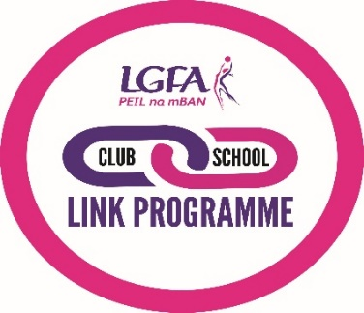
LGFA Club-School Link Agreement Form

A club-school link is an agreement between a Ladies Gaelic Football club and a school, designed to help both parties further their aims and work together to meet the needs of young people, whether they want to get involved:
- As a player to enjoy and develop their skills
- For social or recreational reasons OR to maintain and develop their fitness
- As a young Leader, Coach, Referee or as a Club Volunteer.
This form sets out commitments that the club and school agree to as part of a club-school link.
 |  | Club |  |  |  | School
Club/School Name
Name of Contact
Role of Contact
Telephone
Email
Level Agreed |  | Bronze |  |  | Silver |  |  |  | Gold
Signature (s)
Date |  |  |  | Agreed Review Date

The school and club agree to contact each other regularly with updates. This agreement will be reviewed on the set date to ensure quality, continued planning and progression.
We recommend that a minimum of 3 ‘ticked’ boxes for both school and club to start a school-club link. Boxes or wording can be amended to meet the school and club needs.

The school agrees to… | Tick | The club agrees to… | Tick
Safeguard all young people (compulsory) |  | Safeguard all young people, ensure coaches are qualified and vetted (compulsory)
Ensure up to date club information is made available to pupil and promote club within the school (Noticeboard/hand-outs/newsletter) |  | Provide the school with up to date information and promotional material (e.g. Posters, newsletters, flyers, training/activity details)
Promote opportunities to participate at the club within the school (see ‘list of ideas’) |  | Provide new opportunities for students to participate (see ‘list of ideas’)
Offer Ladies football as a curricular activity to appropriate age groups |  | Provide Coaching support
Offer Ladies football as an extra-curricular activity to appropriate age groups |  | Help to run after school sessions
Ensure a member of staff is available on school site for extra-curricular activity |  | Provide CPD opportunities for both students and staff
Promote opportunities to volunteer at the club within the school (see ‘list of ideas’) |  | Provide the school with information on volunteering roles and support opportunities in the club

List of Ideas

Please select from the below or any additional ideas you might have and agree actions to deliver.

Club could:
- Offer use of their facilities
- Establish a school noticeboard and have up to date information
- Do a talk in school/at assembly to encourage children to join
- Provide a fixture list/calendar of events for young people to participate or gain experience as young leaders/volunteers
- Provide coaches to assist with after school coaching and/or school team
- Run a club open/fun day at the club for the school
- Provide the school with equipment to support the delivery of Ladies football in school
- Provide training for teachers/assistants to deliver sessions confidently
- Help with the organisation of events, sports days if appropriate

School could:
- Offer use of school facilities
- Provide space on the school noticeboard and/or website for club to promote itself and activities
- Advertise the clubs training and competitions
- Invite club coaches/players to speak at assemblies or PTA meetings
- Include the club in the planning of an ‘open week’, have a go activity
- Provide letters of support for funding applications

 | The School Will: | The Club Will:
Action 1

Action 2

Action 3

Action 4

Action 5

Please send completed club-school link forms to: vincent.whelan@lgfa.ie

