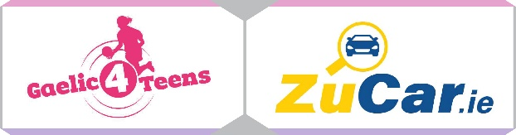
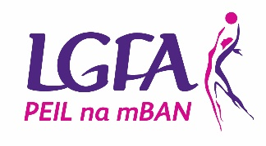

GAELIC4TEENS
2023 Application form

To register your Club’s interest and apply for the 2023 Gaelic4Teens programme, please complete this application form and return it via email to developmentsupport@lgfa.ie by Friday 18th November 2022.

Please Note – All sections must be completed, or the application will not be accepted
Club Name:

County:

Club contact for this application:

Phone: (Home): (Mobile):

Email:

How long is your Ladies Football Club in existence?
MEMBERSHIP FIGURES:
Age Group | Total number of registered members  (Where applicable) | Number of mentors currently involved with the team(s)  (Where applicable)
Under 8
Under 10
Under 12
Under 14
Under 16
Under 17
Under 18
Adult

CATCHMENT SCHOOL INFORMATION (fill in for both programmes)

Name of POST PRIMARY Schools in your area | Mixed/All Girls | Number of Girls aged 13 – 17 years | Catchment Clubs

REASONS TO BE SELECTED:
Please provide 3 reasons why your Club should be selected to host 2023 Gaelic4Teens Programme…

RESOURCES
Please provide list of coaches that will be participating in this programme and indicate what age group they are involved with in the club

Name of  G4T Programme Co-Ordinator | Name of coaches  (Where applicable to your club)
U13

U14

U15

U16

U17 /18

KEY DATES:
PHASE ONE – MAKING SENSE OF THE THEORY
JANUARY 2023
Format | Date | Topic | Target Group
Virtual Classroom (Live Webinar) | Monday 16th January 9pm | Induction | Club Executive and coaches
Virtual Classroom (Live Webinar) | Monday 30th January 8.30pm | Coaching Approach and Behaviours  Receive Sessions 1 to 3 | Coaches

FEBRUARY 2023
Format | Date | Topic | Target Group
Virtual Classroom (Live Webinar) | Monday 6th February 8.30pm | Physical Considerations | Coaches
Virtual Classroom  (Live Webinar) | Monday 20th February 8.30pm | Teaching Games for Understanding  Receive Sessions 4 to 6 | Coaches
Virtual Classroom (Live Webinar) | Monday 27th February 8.30pm | Coaching within the Rules | Coaches

MARCH 2023
Format | Date | Topic | Target Group
Virtual Classroom (Live Webinar) | Monday 27th March 8.30pm | Nutrition/Hydration | Coaches, Players and Parents

APRIL 2023
Format | Date | Topic | Target Group
Virtual Classroom (Live Webinar) | Monday 10th April 8.30pm | Lifestyle Balance | Coaches, Players and Parents

PHASE TWO – PUTTING THE THEORY INTO PRACTICE
Saturday 7th MAY NATIONAL GAELIC4TEENS FESTIVAL DAY
JUNE 2022
Format | Date | Topic | Target Group
Virtual Classroom (Live Webinar) | Monday 12th June 8pm | Peer Coaching Support Programme  Part 1 | Coaches interested in this area
Virtual Classroom (Live Webinar) | Monday 26th June 8pm | Peer Coaching Support Programme  Part 2 | Coaches interested in this area

JULY/AUG 2023
JULY - AUG CLUB COACH OBSERVATION VISITS
PHASE THREE – MAKING IT SUSTAINABLE
SEPTEMBER 2023
Format | Date | Topic | Target Group
Virtual Classroom (Live Webinar) | Wednesday 11th September  8.30pm | Creating Positive Club Coaching Climate Part One | Executive and coaches
Virtual Classroom (Live Webinar) | Wednesday 25th September  8.30pm | Creating Positive Club Coaching Climate Part Two | Executive and coaches
OCTOBER 2022
Format | Date | Topic | Target Group
Virtual Classroom (Live Webinar) | Monday 9^{h} October 8.30pm | Review or Follow Up | Coaches

I confirm that:
- All information supplied in this application form is accurate
- I have read the G4T Overview Booklet in full and will fully comply with all terms and conditions associated with the roll out of the programme
- I understand all dates associated with the programme and understand mandatory attendance of club at same

Signed: Date:

This can be digital signature

Please submit via email to developmentsupport@lgfa.ie by Friday 18th November 2022.

Please note that any applications received after the closing date will not be considered for the Gaelic4Teens programme this year.

