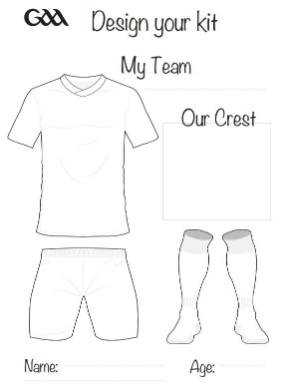

**New York**

1. **Mairead Tamayne**

Rockland GAA

**2. Aoife Mathers 3.Sara Roche 4 Keva Moore**  Shannon Gaels NY Kerry/Donegal LFC Shannon Gaels NY

**5. Lauren Rodican 6. Ciara O Neill 7. Sinead McGourty**

Leitrim Ladies NY Leitrim Ladies NY St Brigids LGFC NY

**8. Margaret Brady 9. Megan Fitzpatrick**

Na Fianna Ladies NY  Leitrim Ladies NY

**10. Paula Clarke 11.Emma Farley 12. Courtney Traynor**  Cavan Ladies NY GAA O Donovan Rossa LGA NY Kerry/Donegal LGFC

**13. Marie Dargan 14. Kelly Brady 15. Kelly Keating (C )**  Kerry/Donegal LGFC Rockland GAA Kerry/Donegal LGFC

Mna Ionaid:

16. 16. Michelle Dowd Kerry/Donegal LGFA

17. 17. Madison Donohoe St Brigids LGFC NY

18. 18. Lily Sheahan St Brigids LGFC NY

19. 19. Caroline McBrien Cavan Ladies NY GAA

20. 20. Shauna McGrath Leitrim Ladies NY

21. 21. Sorcha Ni Bhraonáin Cavan Ladies NY GAA

22. 22. Claire Cunninghma O Donovan Rossa LGAA NY

23. 23. Annie White Rockland GAA

24.Laura Wynne Leitrim Ladies NY

Manager: Rosie O’ Reilly Mentor: Simon Gillespie

**Manager: Rosie O Reilly**

**Mentors: Simon Gillespie**

**Antrim**

**1. Anna McCann**

St Ergnats

**2. Duana Coleman 3. Aislinn McFarland 4. Niamh McIntosh**

Sarsfields *Bredagh* St Ergnats

**5. Maeve Mulholland 6. Saoirse Tennyson 7. Sarah O Neill**

Con Magees Naomh Pol St Ergnats

**8. Clare Emerson 9. Aine Tubridy**

Con Magees Naomh Pol

**10. Grainne McLaughlin 11. Cathy Carey (C) 12. Maria O Neill**

Glenavy St Ergnat’s St Ergnats

**13. Bronagh Devlin 14. Orlaith Prenter 15. Caitlin Taggart**

St Ergnat’s St Ergnat’s Aldergrove

**Mna Ionaid:**

16. Emily McCoy St Ergnat’s

17. Aine Devlin St Ergnats

18. Molly Woulahan Con Magees

19. Emma Louise McAreavey St Ergnats

20. Ellie Murphy Naomh Pol

21. Maria McKenna Con Magees

22. Orla Corr Naomh Eoin

23. Megan McGarry Glenavy

24. Omolara Dahunsi Naomh Pol

25. Grace Shannon Rossa

26. Aoife Taggart Aldergrove

27. Danielle Connolly St Ergnats

28. Michelle Magee Carryduff

29. Theresa Mellon Naomh Brid

**Manager: Emma Kelly**

**Mentors: Kyla Trainor, Ursula Madden, Liam Taggart,**

**Physio: Ian McIlfatrick**

Sunday

19th June 2022

2pm. Davitt Park.

Referee: Angela Gallagher, Dublin

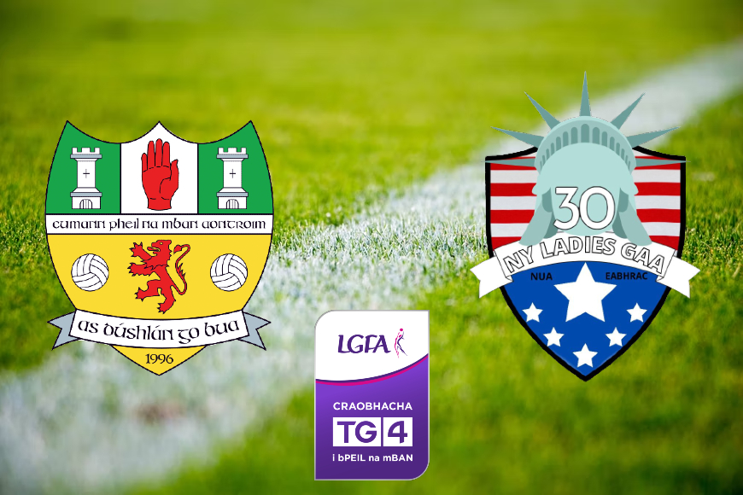



Antrim

V

New York

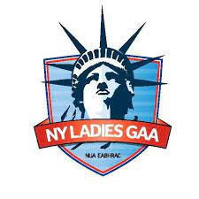



Louth

Venue: Rathmore GS

Date: 25thh March 2018

Time: 2.00pm

Réiteoir: D Kearns