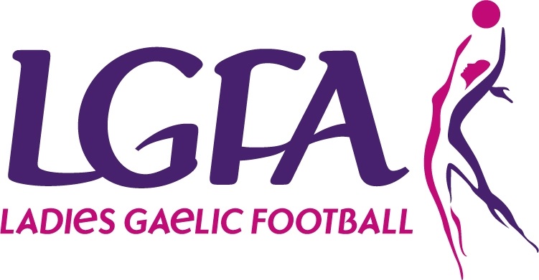
All-Ireland Finals
Half-Time Exhibitions
Application Cover Form
PLEASE BLOCK PRINT ALL DETAILS

Club Name: _____________________________________

County: _____________________________________

Contact Name: _________________________________________

Postal Address: _________________________________________

_________________________________________

_________________________________________

Contact Number: _______________________

Email Address: ________________________________________

Please note all notifications and correspondence will be sent to the above contact details.

WHAT IS THE CRITERIA? WHAT IS INVOLVED ON THE DAY?

Please mark X the category your Club wishes to enter. Your Club may only enter ONE Category.

- U-12 Exhibition Games
- 4 places available for the U-12 Exhibition Games
- 10 x U-12* Players from each of the 4 selected clubs, will participate in an Exhibition Game during half-time of one of the All-Ireland Championship Finals on the 30th September 2012 in Croke Park
- As part of the day, the 10 players will receive a unique set of gear(designed specifically for All-Ireland Finals’ Day), and a packed lunch
- Two mentors (per Club) will be required to attend on the day also
- The 10 players and 2 mentors will receive 2 complimentary tickets each. As this is a very special occasion for your Club and certainly for the 10 players, their names and Club name will appear in the All-Ireland Finals Programme, which each player will receive as a souvenir of their trip to Croke Park.

* The players selected for the U-12 Team must be born in either 2000 or 2001.

2. U-16 Exhibition Games
- 4 places available for the U-16 Exhibition Games
- 10 x U-16* Players from each of the 4 selected clubs, will participate in an Exhibition Game during half-time of one of the All-Ireland Championship Finals on the 30th September 2012 in Croke Park
- As part of the day, the 10 players will receive a unique set of gear (designed specifically for All-Ireland Finals’ Day), and a packed lunch
- Two mentors (per Club) will be required to attend on the day also
- The 10 players and 2 mentors will receive 2 complimentary tickets each
- As this a very special occasion for your Club and certainly for the 10 players, their names and Club name will appear in the All-Ireland Finals Programme, which each player will receive as a souvenir of their trip to Croke Park.

* The players selected for the U-16 Team must be born in either 1996 or 1997.

3. Gaelic4Mothers & Others Exhibition Games
- 4 places available for the Gaelic4Mothers & Others Exhibition Games
- 10 x Players* from each of the 4 selected clubs**, will participate in an Exhibition Game during half-time of one of the All-Ireland Championship Finals on the 30th September 2012 in Croke Park
- As part of the day, the 10 players will receive a unique set of gear (designed specifically for All-Ireland Finals’ Day), and a packed lunch
- Two mentors, per Club, will be required to attend on the day also. The 10 players and 2 mentors will receive 2 complimentary tickets each
- As this a very special occasion for your Club, and certainly for the 10 players, their names and Club name will appear in the All-Ireland Finals Programme, which each player will receive as a souvenir of their trip to Croke Park.

* The players selected for the Gaelic4Mothers &Others Team must be registered members of the Association.
** Only registered Gaelic4Mothers &Others Clubs may enter the competition.

4. U-14 Officials for Exhibition Games
- 3 places available for the U-14 Officials for the Exhibition Games
- 12 x U-14* Players from each of the 3 selected clubs, will act as the Officials (8 umpires and 4 linespeople) for the Exhibition Games during half-time of one of the All-Ireland Championship Finals on the 30th September 2012 in Croke Park
- As part of the day, the 12 players will receive a unique set of gear to officiate in, which is designed specifically for All-Ireland Finals’ Day and a packed lunch
- Two mentors (per Club) will be required to attend on the day also
- The 12 players and 2 mentors will receive 2 complimentary tickets each
- As this a very special occasion for your Club and certainly for the 10 players, their names and Club name will appear in the All-Ireland Finals Programme, which each player will receive as a souvenir of their trip to Croke Park.

* The players selected for the U-14 Officials must be born in either 1998 or 1999.

5. U-14 Ball-girls for the 2012 All-Ireland Championship Finals

- There is only 1 place available for the role as Ball-girls for the 2012 All-Ireland Championship Finals on the 30th September in Croke Park
- 12 x U-14* Players from the selected club, will act as the Ball-girls, 4 players per Final
- The Ball-girls play a vital role on the day, as all 3 All-Ireland Finals are televised live. The Ball-girls must be fully aware of their duties, not interfering with play but assist the goalkeeper in retrieving the ball as quickly as possible. The duties of the ball girls will be explained fully to the girls prior to the games.
- As part of the day, the 12 players will receive a set of gear and a packed lunch
- 4 mentors from the Club will also be required to attend on the day
- The 12 players and 4 mentors will receive 2 complimentary tickets each
- As this a very special occasion for your Club and certainly for the 12 players, their names and Club name will appear in the All-Ireland Finals Programme, which each player will receive as a souvenir of their trip to Croke Park.

* The players selected for the U-14 Ball-girls must be born in either 1998 or 1999.



