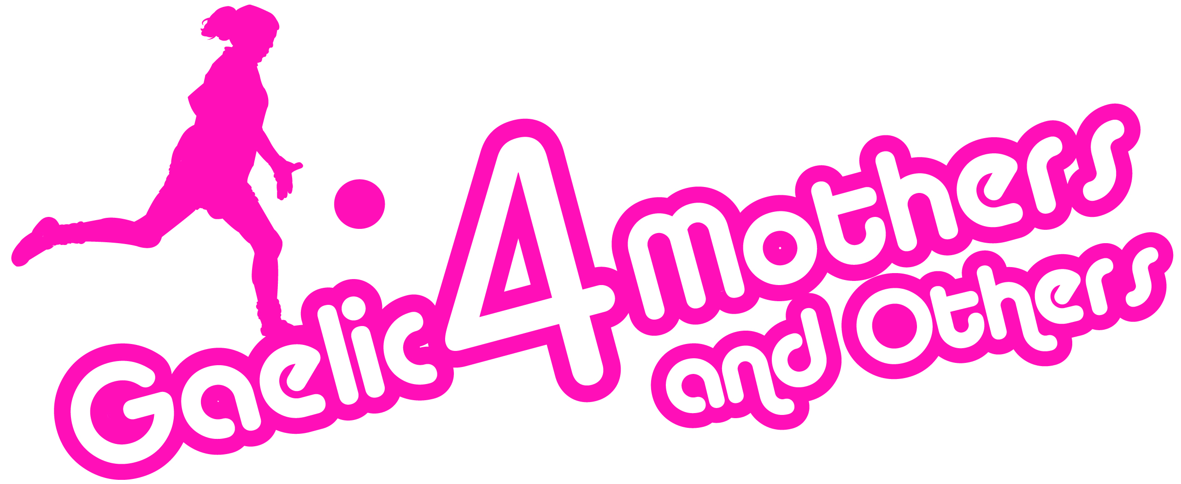

Gaelic4Mothers&Others Provincial Training Evenings Details

Who is the training open to?
- Existing G4M&O Clubs/sites
- Clubs or Persons that wish to set up G4M&O Programme in 2014
Who should attend the training?
- Existing, new or potential G4M&O club/site co ordinators
- Existing, new or potential G4M&O club/site coaches
What will the training entail?
- Programme will assist with the following from a co ordinator and coaches point of view.
  - Information on the new Gaelic4Mothers&Others Programme format and guidelines to be followed
  - The different steps involved with the G4M&O Programme
  - How to plan and prepare for each step
  - Motivate clubs to run a successful programme in your area
How long will the training be?
- Session will be 1 Hour and 30 minutes max. This will include both theoretical and practical element.

Please confirm your attendance with below contact in your Province
Munster  Date: Tuesday 8th April  Venue: Mallow GAA Complex  Time: 7.15pm  Who to Contact: Ian O Brien  Contact Number: 086 2575860  Contact Email:  Ianob1@yahoo.ie | Ulster  Date: Wednesday 9th April  Venue: Donaghmore GFC (Torrent Complex), Tyrone  Time: 7.30pm  Who to Contact: Sheena Kelly  Contact Number: 07795160979  Contact Email:  sheena.kelly.ulster@gaa.ie
Leinster  Date: Wednesday 9th April  Venue: St. Maurs GAA Club, Rush, Dublin  Time: 7.30pm  Who to Contact: Aisling Hubbard  Contact Number: 087 7681288  Contact Email:  gdo@leinsterladiesgaelic.ie | Connacht  Date: Thursday 10th April  Venue: Connacht GAA Centre of Excellence  Time: 7.30pm  Who to Contact: Noelle Gormley  Contact Number: 086 4133538  Contact Email:  ngconnachtdev@gmail.com

