ourClub Logo

Registration Form

Name/Team: ___________________________________
Contact Number or Email:________________________

SIZE | 5-6yr | 7-8yr | 9-11yr | 12-13yr | S | M | L | XL | XXL
Female
Male

- If Mentors are filling in players sizes fill them in in block e.g. 10/12-13, 10/Sml, if individual entry just put an X in the box required e.g. For Adults X the box M or F
*NB – REGISTRATION NIGHT WEDNESDAY 5TH NOVEMBER
BALLYBODEN ST ENDA’S 8pm – 10pm
REGISTRATION €10.00 (includes t-shirt)
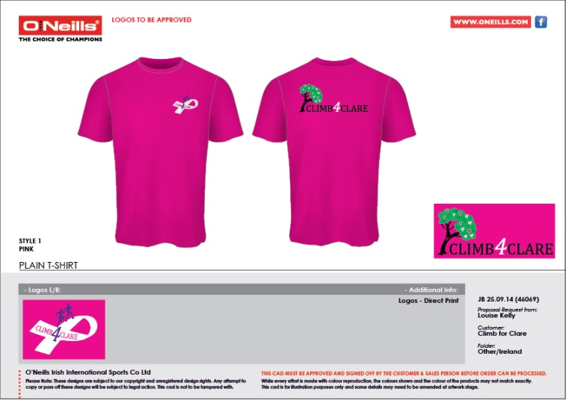
Thank you very much for your support

