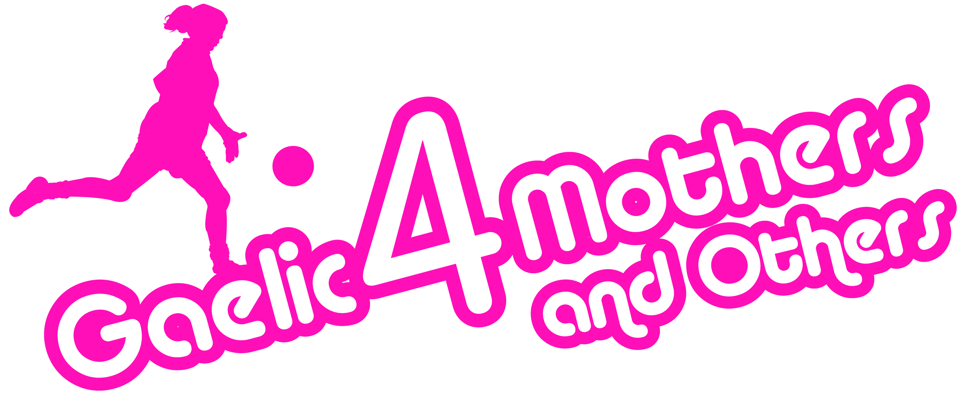

G4M&O Merchandise Price List

G4M&O Jerseys €20
Umbrellas €5
Travel Mugs & Tea Bags €3
Water Bottles €3
Shopping Bags €2

Cash Only! No facilities for Cards.

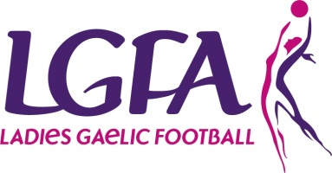
LGFA All Star Gear Price List

Toronto All Star Gear
White Hooded Top €15
Navy Full Zip Top €15
V-Neck/Collared T-shirt €10
Navy, Pink & Blue Bottoms €10
All Star Jersey €20

Hong Kong All Star Gear
Black Full Zip Top €30
Blue ½ Zip Top €30
All Star Jersey €35

Cash Only! No facilities for Cards.

LGFA Merchandise Price List

Gaelic4Girls Backpacks €5

BGE Team of League Jersey €10

Climb4Clare T-Shirts €10

Cash Only! No facilities for Cards.

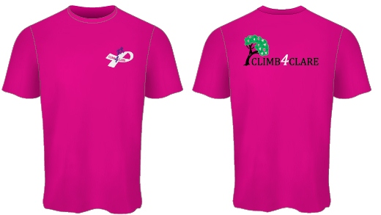
All Proceeds to Climb4Clare

Official T-Shirts Only €10

