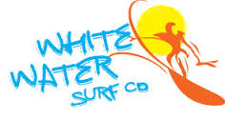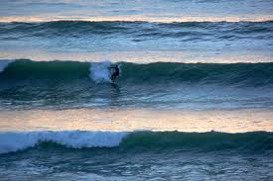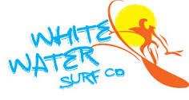
Come join us at
Ladies Football Surf Lessons

White Water Surf School
In Spanish Point for
• 2 hour surf lesson.
• All equipment provided.
• Followed by a BBQ on the beach.
• All for 20 Euro per person.
Tel: 086 8625564
Email: info@whitewatersurfco.com www.whitewatersurfco.com
Our ISA approved surf school operates from Spanish Point beach. White Water Surf Co. was founded in 2007 by local surfer Pat “Preacher” Keane who has been surfing in this area since the late 70's, so when you come to us you know that you are benefiting from over three decades of local knowledge.

