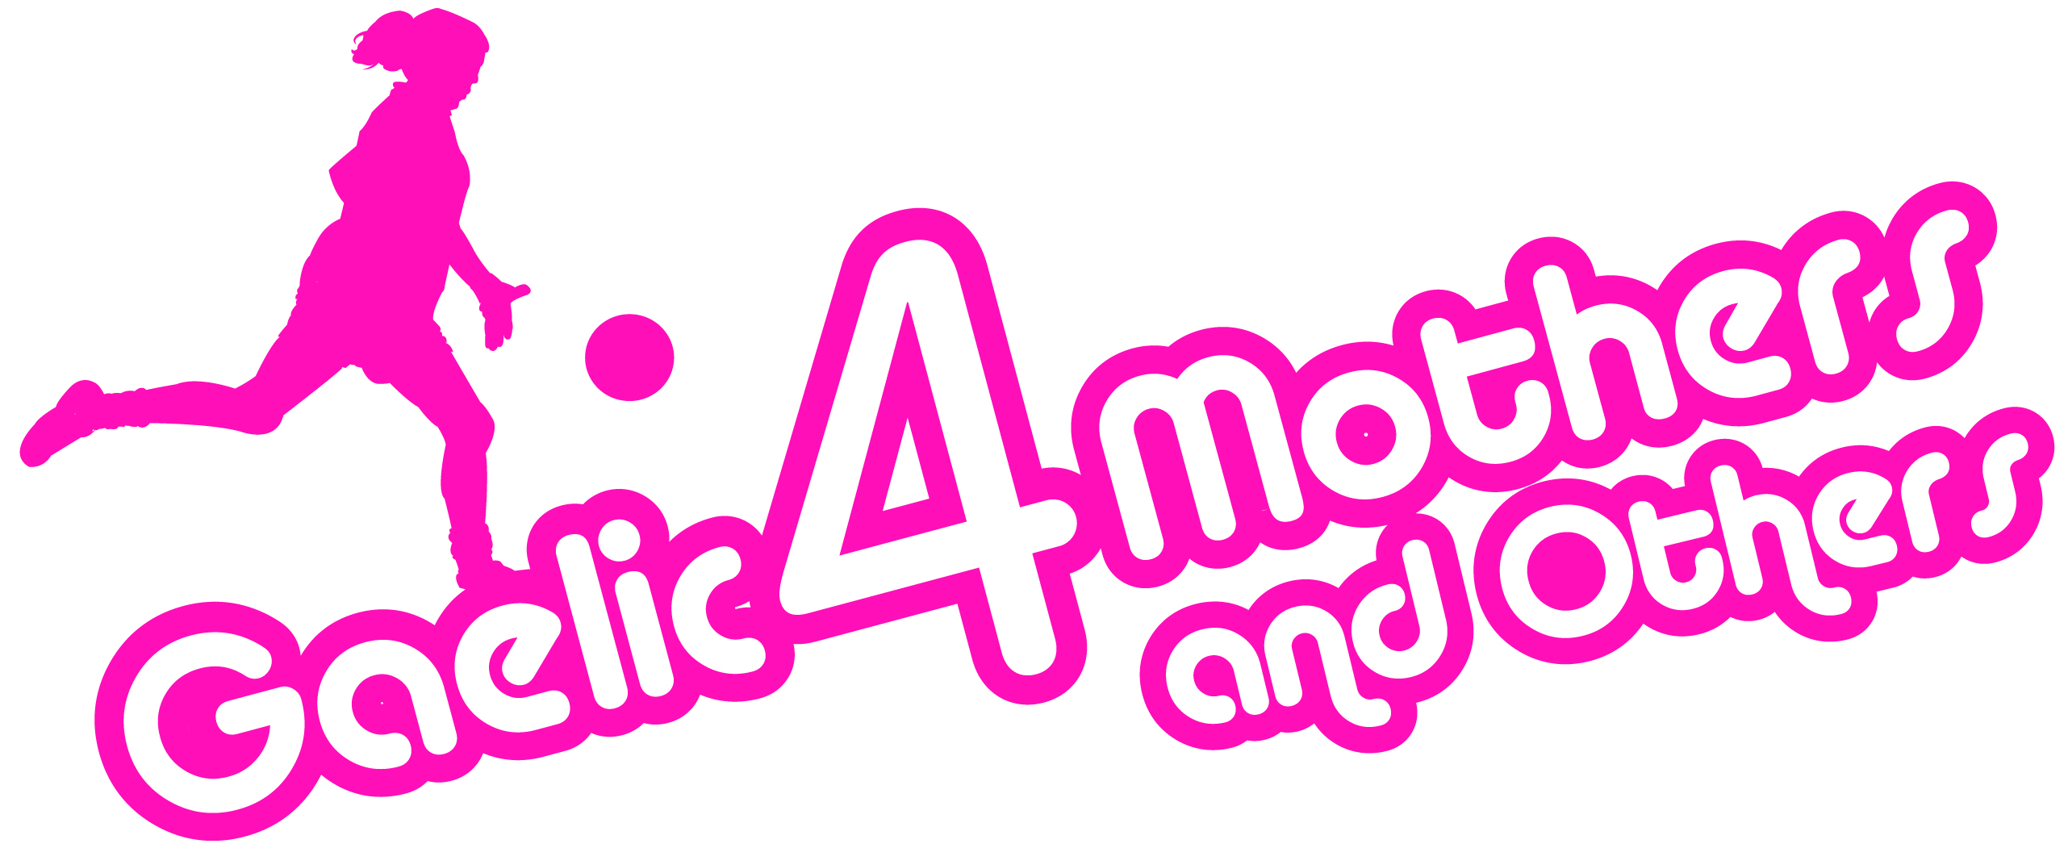
2016 Gaelic4Mothers&Others
NATIONAL BLITZ ENTRY FORM

Please complete Entry form and return with appropriate Entry Fee it to Cliodhna O’Connor, by 16th September 2016 via Post (LGFA, Croke Park, Dublin 3) or email (Cliodhna.oconnor@gmail.com)

Please Note – All sections must be completed
Club Name: _____________________________________________________
County: ________ ____________________________________________
Team Contact Name: _____________________________________________________
Phone: (Mobile): ___________________________________________
Email: _______________________________________________
Club Colours: _______________________________________________
Number of years Club is running G4M&O Initiative ________________________
Total Number of Players:________ (20 players maximum per Team)
Interested in entering a 2nd team if availability arises: Yes _______ No _______

All players must be registered members with the LGFA – checks will be carried out prior to the blitz
Payment Details
Payment Type: Cash ________ Cheque ________ Credit Card ________ Postal Order ________
(Please ensure all Cheques/Postal Orders are made payable to the LGFA)
Credit Card Details
Card Type _______________________Name on Card _______________________________________
Card Number __________________________________
Expiry Date ________________ Security Code (last 3 digits on back of card) _________
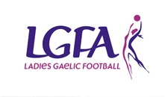
Total Payment Amount: ______________________

