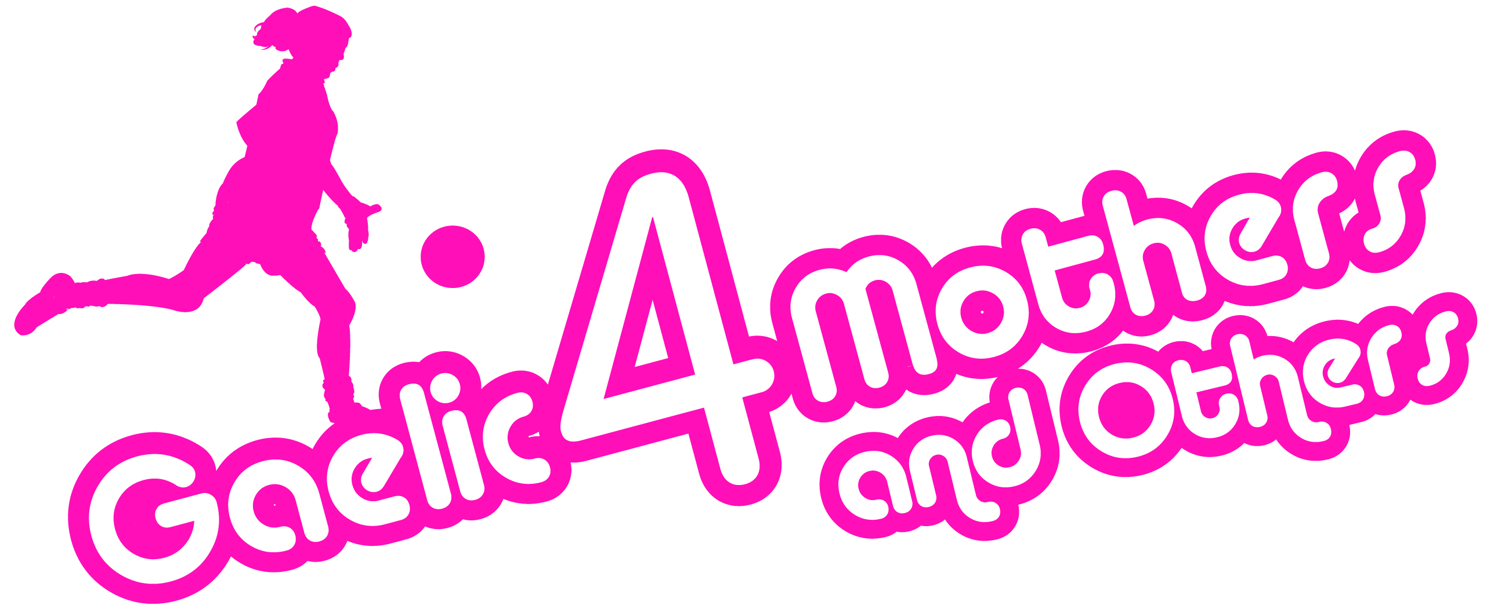
NATIONAL BLITZ FANCY DRESS DINNER 2016
BOOKING FORM

This year we are introducing a fancy dress dinner and this is sure to be a great night with live music and DJ until the late hours. There are only 250 places available so it is essential to complete this form and return with payment by 1st July.

Please Note – All sections must be completed

Club: ___________________________________________________________
Contact: ___________________________________________________________
Phone: (Mobile): _____________________ Email: _________________________________

Number of Tickets | _______ @ €25 each
Total Payment Due | €_____

Payment details
Cheque: (made payable to Ladies Gaelic Football Association)

Credit Card:
Card Number: ____________________________________
Expiry Date: _____________ Sec Code: ___________

Signed: _________________________________ Date: _______________________________

Please submit to: Cliodhna O’Connor, LGFA, Croke Park, Dublin 3

or email cliodhna.oconnor@lgfa.ie

Please note that orders will not be accepted without full payment and

also there will be no refunds available.

