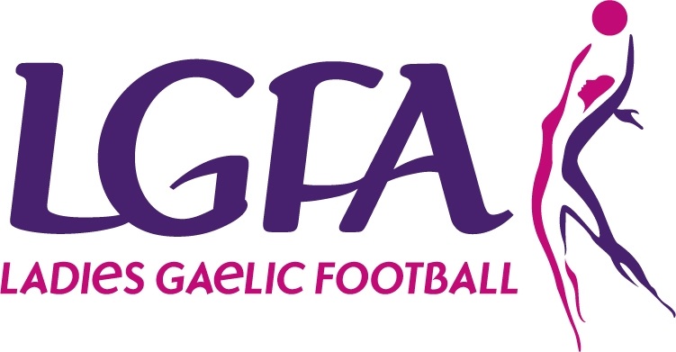
All-Ireland Finals
Half-Time Exhibition Games
Entry Details
Ever imagine that you would play in
Croke Park on All Ireland Finals Day?
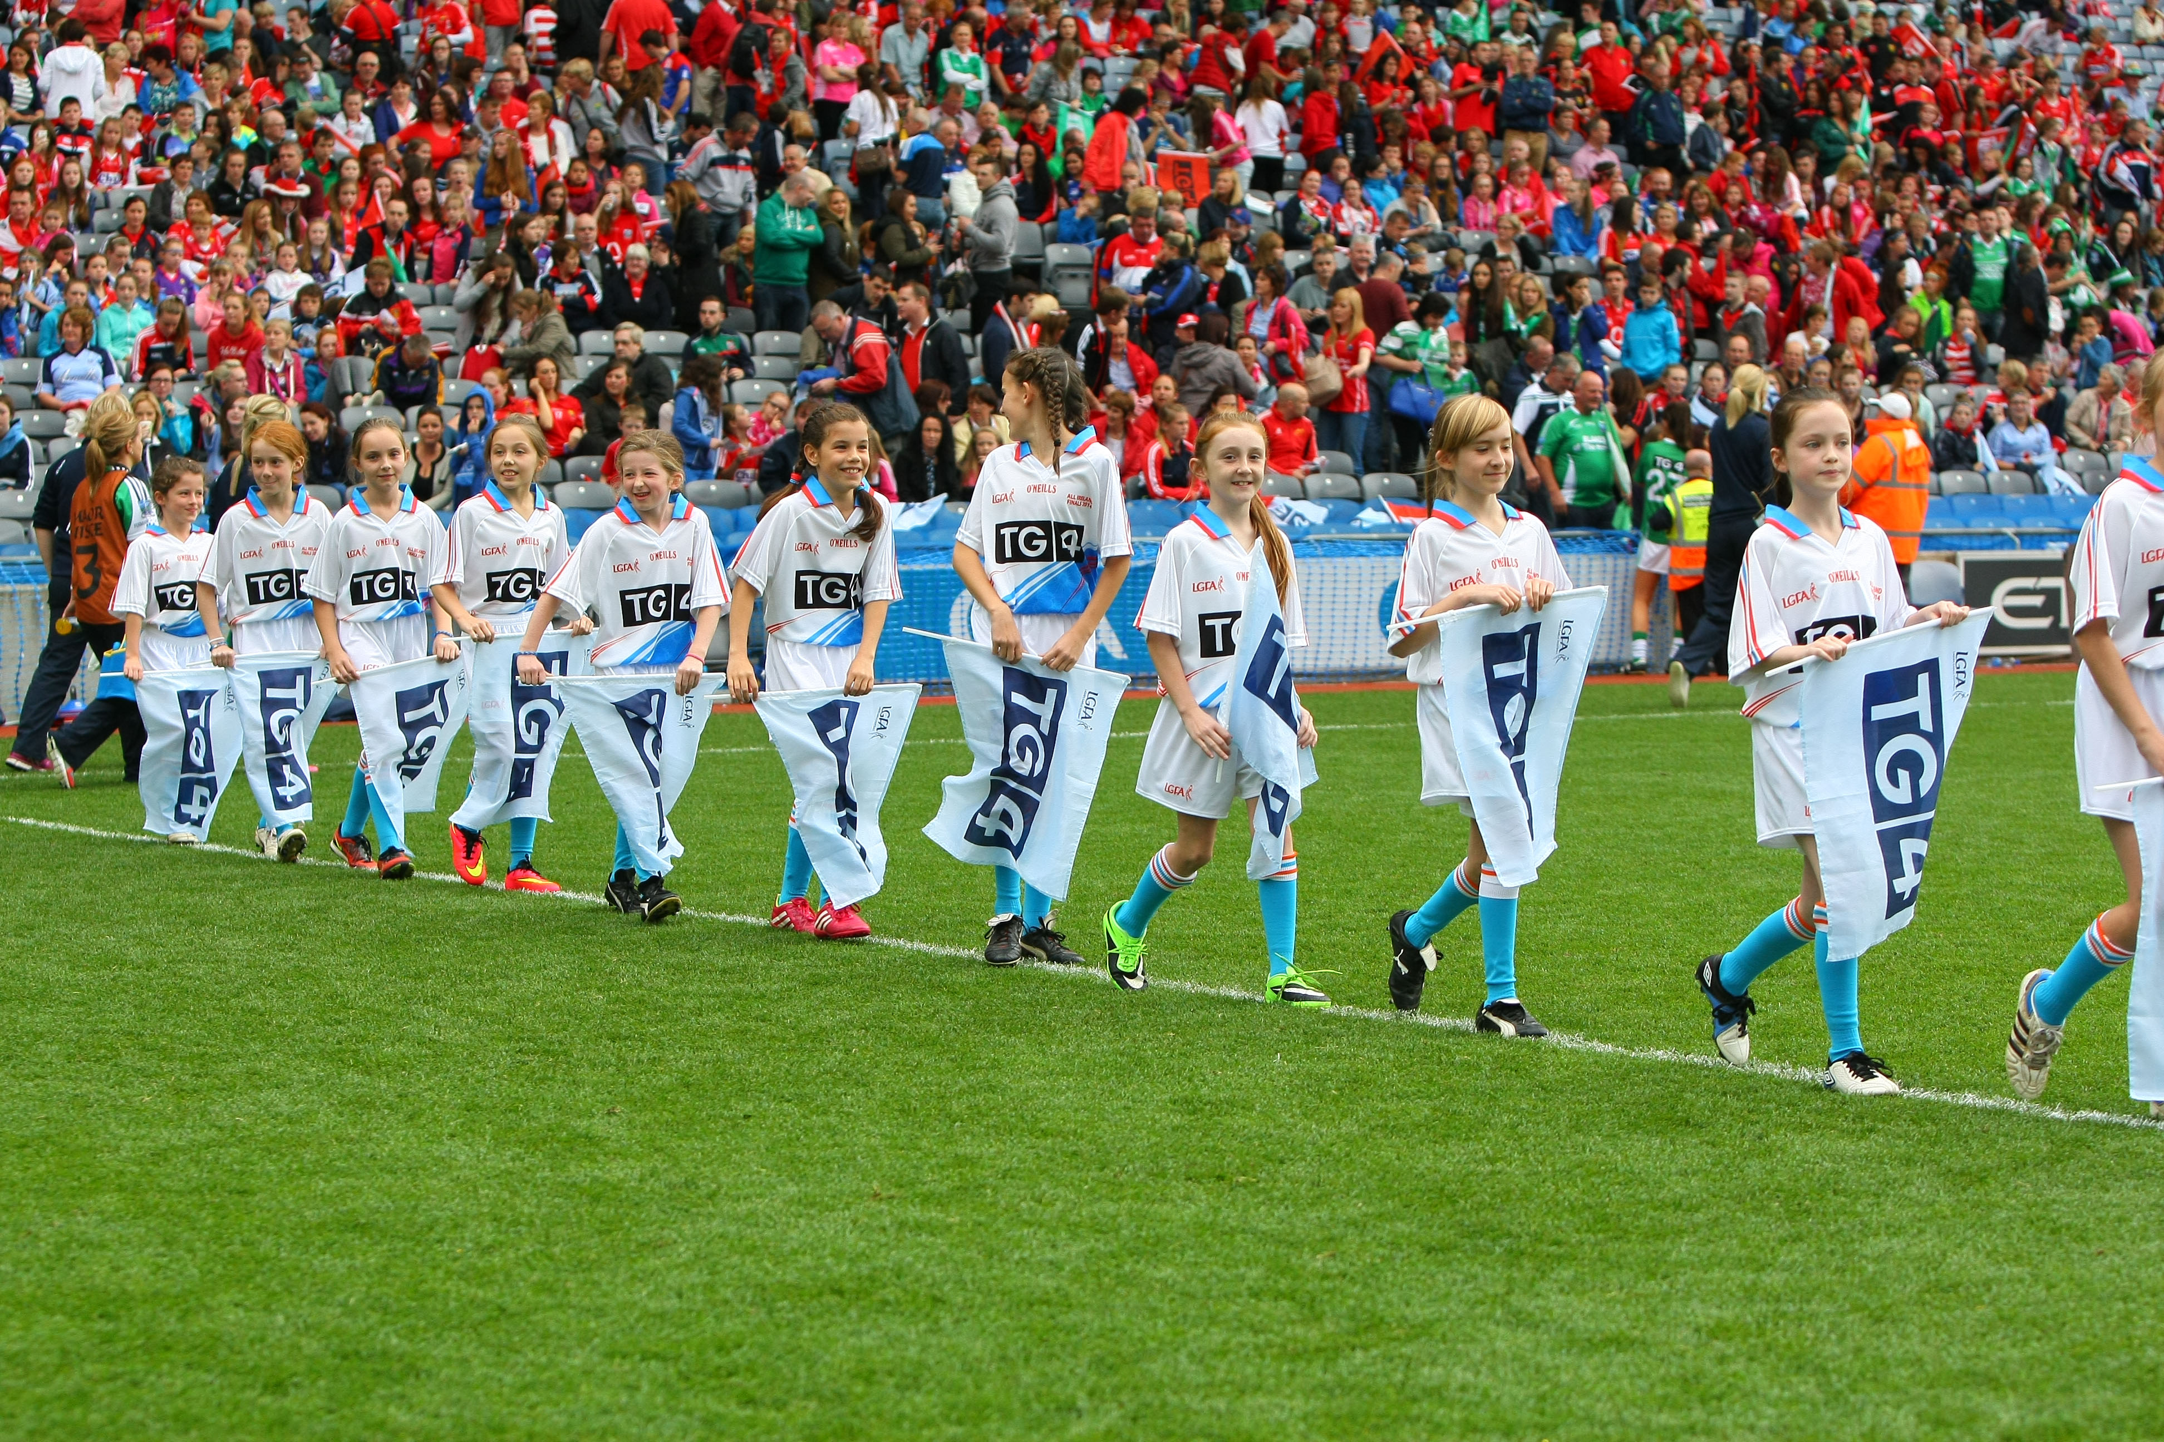

The Ladies Gaelic Football Association is giving your Club the chance to play or officiate during the
TG4 Ladies Gaelic All Ireland Finals Day in Croke Park

WHAT IS INVOLVED?

In order to allow as many LGFA members as possible to experience the buzz and excitement of TG4 Ladies Gaelic All Ireland Finals Day on the 24th of September 2017 the Ladies Gaelic Football Association are looking for the following club teams to get involved:
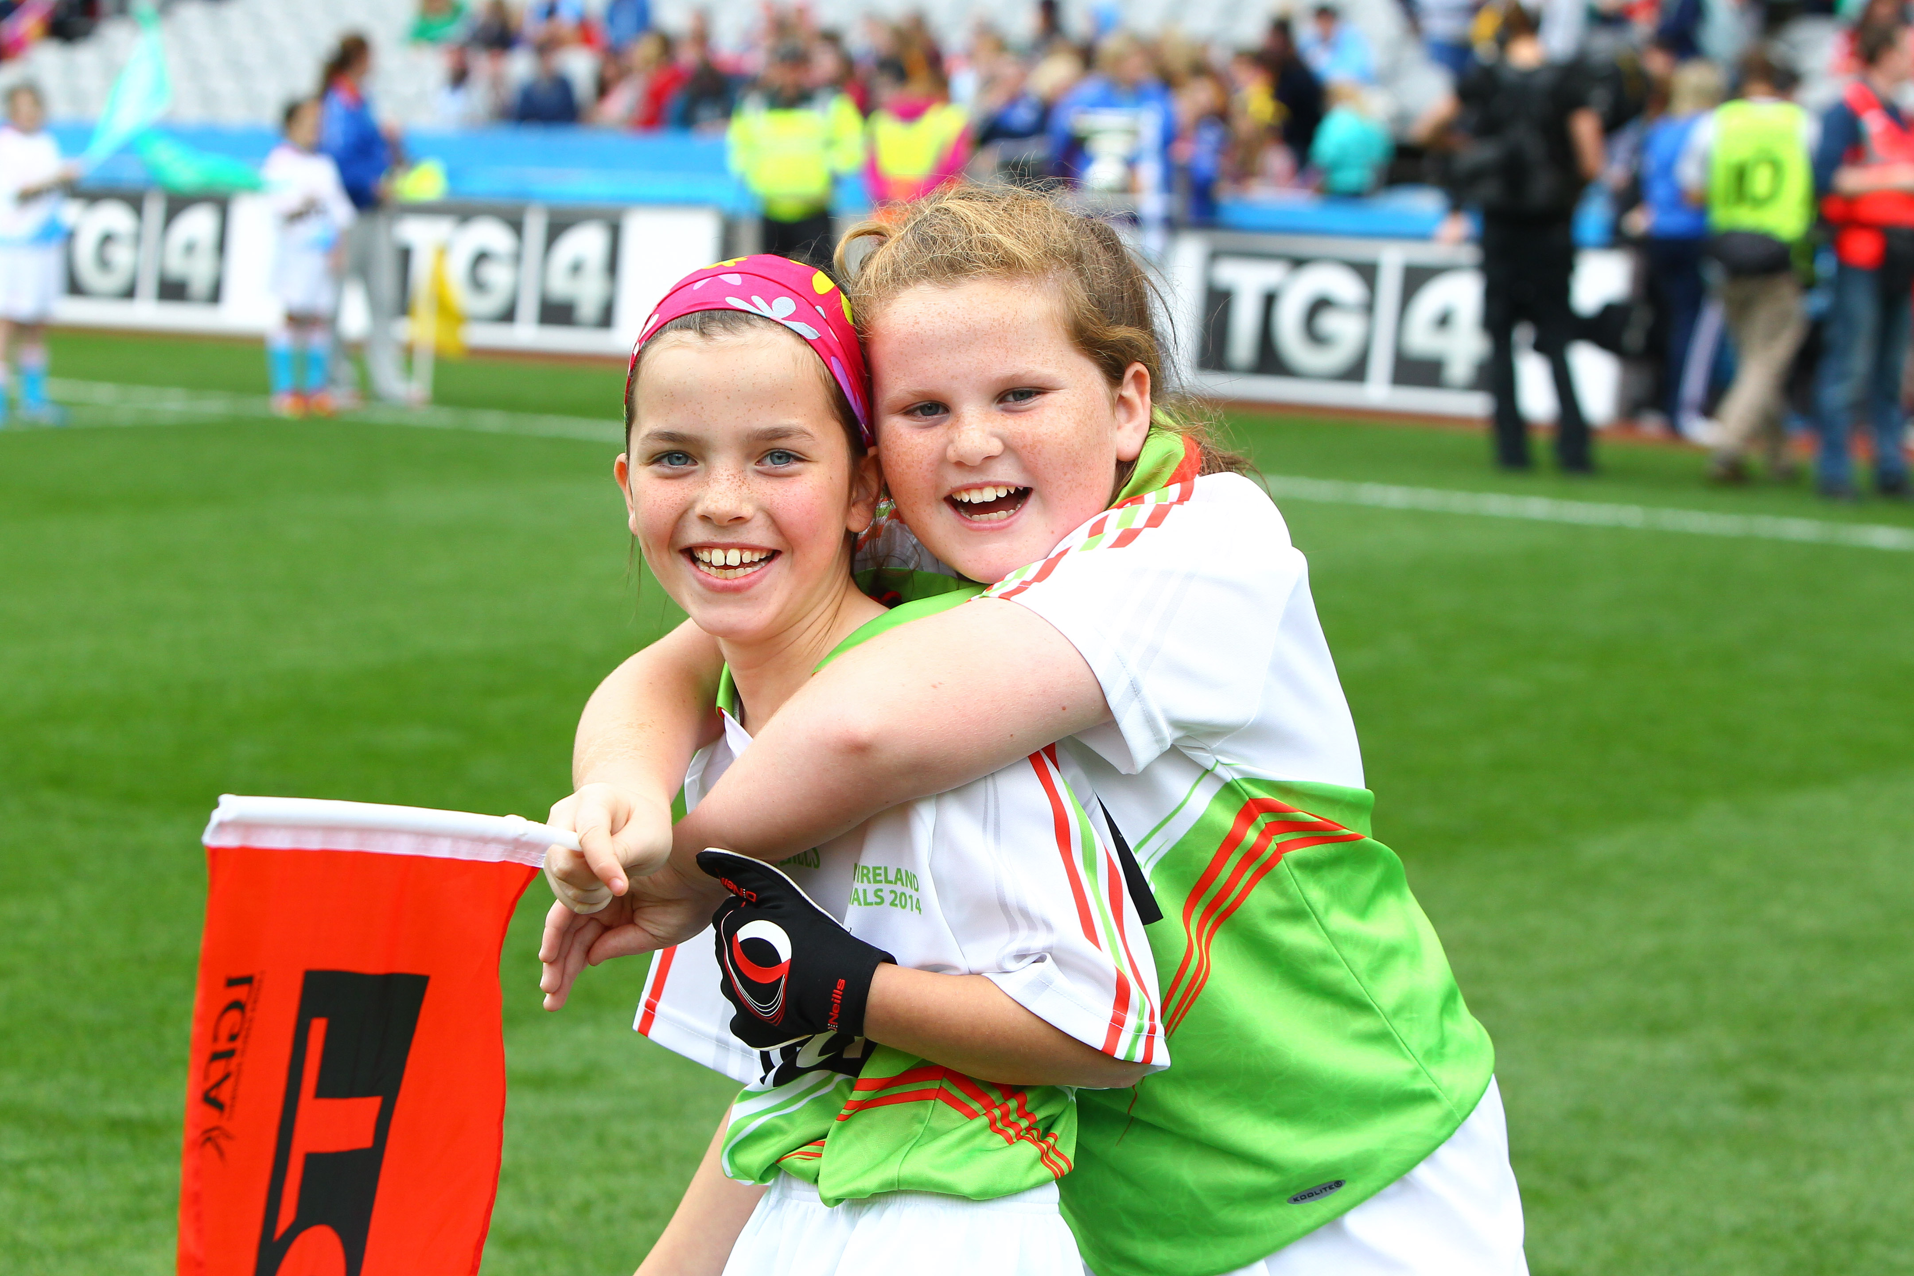
- To play at half time of the 3 TG4 Championship Finals:
- 6 U10 teams,
- U10 Teams will consist of 12 players per team
- 6 Gaelic4Mothers & Others teams,
- G4M&O teams will consist of 10 Players per team.

- To officiate at the half time Exhibition Games:
- 3 U14 Teams (12 Players per team)

- To assist as Ball Girls during the 3 All-Ireland Championship Finals
- 1 U14 team (12 players per team)

HOW DO YOU ENTER??

To enter all your Club needs to do is:

- Select the Category your club would like to apply for (See Criteria). Please note only ONE category can be selected.
- Complete the application form provided
- Forward on the supporting documentation that must accompany the application form outlining why your club should be considered for the opportunity to be in the heart of the action on Ladies All Ireland Final Day in Croke Park on Sept 24th 2017. This may be in the form of a poster, picture, poem, story, media video or audio clip etc.

WHO DO WE FORWARD THE ENTRIES TO?

The Application form along with all supporting documentation must be submitted to Paula Prunty by email paula.prunty@lgfa.ie before Friday 18th August.
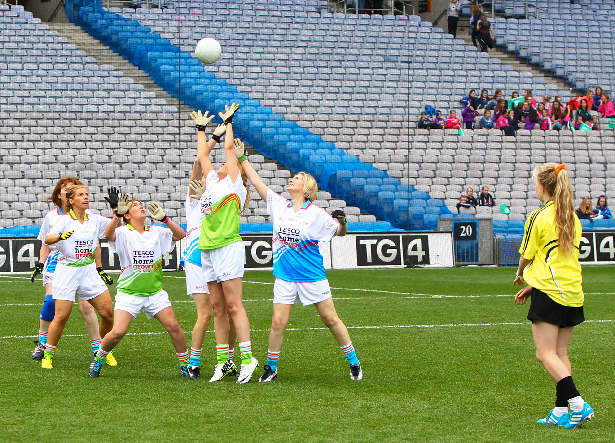

2017 All-Ireland Finals
Half-Time Exhibition Games
Application Form
PLEASE BLOCK PRINT ALL DETAILS

Club Name

County

Contact Name

Contact Number
Contact Postal Address

Contact Email Address

Category Applying For
(See Criteria)

Supporting Document Submitted
(this document should outline why your club should be selected)

Please note all notifications and correspondence will be sent to the above contact details
All-Ireland Finals – Half Time Exhibition Games CRITERIA

Your Club may only enter ONE Category.

Category One U-10 Exhibition Games
- 6 places available for the U-10 Exhibition Games
- 12 x U-10* Players from each of the 6 selected clubs, will participate in an Exhibition Game during half-time of one of the All-Ireland Championship Finals on the 24th September 2017 in Croke Park
- As part of the day, the 12 players will receive a unique set of gear (designed specifically for All-Ireland Finals’ Day), and a packed lunch
- Two mentors (per Club) will be required to attend on the day also
- The 12 players will receive 2 complimentary tickets each. As this is a very special occasion for your Club and certainly for the 12 players, their names and Club name will appear in the All-Ireland Finals Programme, which each player will receive as a souvenir of their trip to Croke Park.

* The players selected for the U-10 Team must be born in either 2007 or 2008

Category Two Gaelic4Mothers & Others Exhibition Games
- 6 places available for the Gaelic4Mothers & Others Exhibition Games
- 10 x Players* from each of the 6 selected clubs**, will participate in an Exhibition Game during half-time of one of the All-Ireland Championship Finals on the 24th September 2017 in Croke Park
- As part of the day, the 10 players will receive a unique set of gear (designed specifically for All-Ireland Finals’ Day), and a packed lunch
- Two mentors, per Club, will be required to attend on the day also. The 10 players will receive 2 complimentary tickets each
- As this a very special occasion for your Club, and certainly for the 10 players, their names and Club name will appear in the All-Ireland Finals Programme, which each player will receive as a souvenir of their trip to Croke Park.

* The players selected for the Gaelic4Mothers &Others Team must be registered members of the Association
** Only registered Gaelic4Mothers &Others Clubs may enter the competition

Category Three U-14 Officials for Exhibition Games
- 3 places are available for the U-14 Officials for the Exhibition Games
- 12 x U-14* Players from each of the 3 selected clubs, will act as the Officials (8 umpires and 4 linespeople) for the Exhibition Games during half-time of one of the All-Ireland Championship Finals on the 24th September 2017 in Croke Park
- As part of the day, the 12 players will receive a unique set of gear to officiate in, which is designed specifically for All-Ireland Finals’ Day and a packed lunch
- Two mentors (per Club) will be required to attend on the day also
- The 12 players will receive 2 complimentary tickets each
- As this a very special occasion for your Club and certainly for the 12 players, their names and Club name will appear in the All-Ireland Finals Programme, which each player will receive as a souvenir of their trip to Croke Park.

* The players selected for the U-14 Officials must be born in either 2003 or 2004

Category Four U-14 Ball-girls for the 2017 All-Ireland Championship Finals
- There is only 1 place available for the role as Ball-girls for the All-Ireland Championship Finals on the 24th September 2017 in Croke Park
- 12 x U-14* Players from the selected club, will act as the Ball-girls, 4 players per Final
- The Ball-girls play a vital role on the day, as all 3 All-Ireland Finals are televised live. The Ball-girls must be fully aware of their duties, not interfering with play but assist the goalkeeper in retrieving the ball as quickly as possible. The duties of the ball girls will be explained fully to the girls prior to the games.
- As part of the day, the 12 players will receive a set of gear and a packed lunch
- 4 mentors from the Club will also be required to attend on the day
- The 12 players will receive 2 complimentary tickets each
- As this a very special occasion for your Club and certainly for the 12 players, their names and Club name will appear in the All-Ireland Finals Programme, which each player will receive as a souvenir of their trip to Croke Park.
* The players selected for the U-14 Ball-girls must be born in either 2003 or 2004

