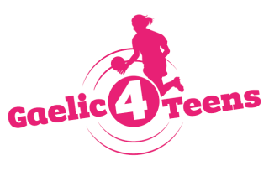
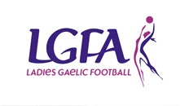
2017 GAELIC4TEENS
Application form

To register your Club’s interest and apply for the Gaelic4Teens 2017 programme, please complete this application form and return it to Paula Prunty, National Development Manager by 16th January 2017.

Please Note – All sections must be completed or the application will not be accepted

Club Name: ___________________________________________________________
County: ___________________________________________________________
Club contact for this application: ___________________________________________________________
Phone: (Home): ___________________ (Mobile): _____________________
Email: ___________________________________________________________
How long is your Ladies Football Club in existence? ___________________________________________
Age Group | Total number of registered members | Number of mentors currently involved with the team(s)
Under 15
Under 16
Under 17

Name of Post Primary Schools in your area | Mixed/All Girls | Number of Girls aged 15 – 17 years

Please give the top 3 reasons why your Club should be selected to host the Gaelic4Teens Programme in 2017?

Please provide evidence to indicate that your Club has the sufficient resources to host the Gaelic4Teens Programme;
Facilities:

Co-ordinator:

Coaches (min. of 3 required):
Under 16 -
Under 18 -
Other -

Equipment:

Signed: _________________________________ Date: _______________________________

Please submit by post to Paula Prunty, National Development Officer, LGFA, Croke Park, Dublin 3 or email Paula on paula.prunty@lgfa.ie. Contact: (01) 8363156

Please note that any applications received after the closing date (16th January 2017) will not be considered for the Gaelic4Teens programme this year.

