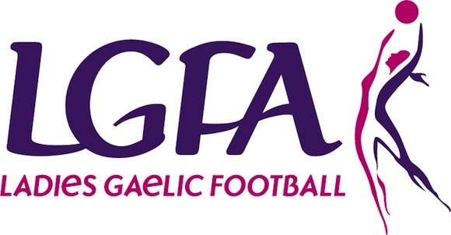
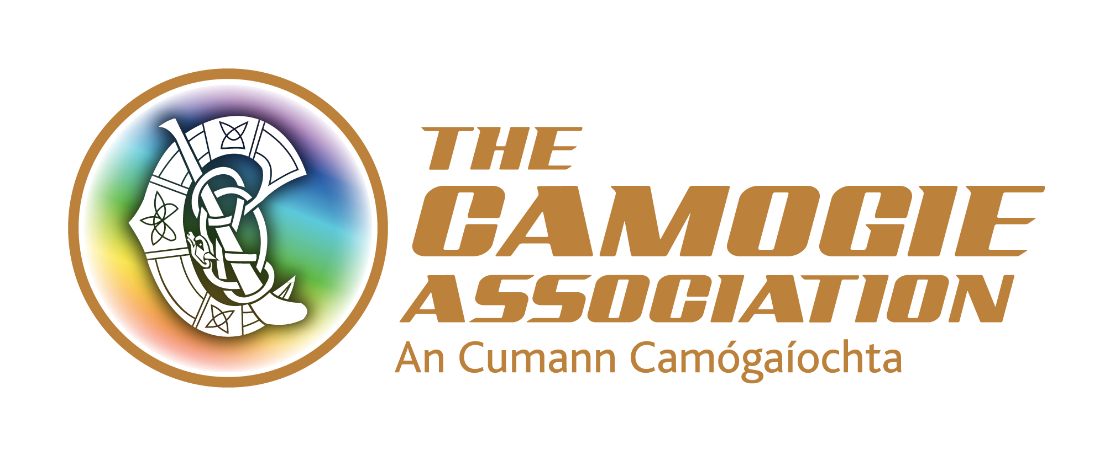


LADIES GAELIC FOOTBALL ASSOCIATION & THE CAMOGIE ASSOCIATION

ROLE DESCRIPTION

Job Title: Contract for Service for Part-Time Government Support Scheme Administrator

Location: Home Based

Responsible to: Chief Executive Officers of LGFA and The Camogie Association

Duration of Post: Two-year contract, with a probationary period of 6 months, extendable to a max of 12 months. Contract is for approximately 100 days a year.

- ROLE PURPOSE

The successful applicant will report to the Chief Executive Officers of the Ladies Gaelic Football Association and The Camogie Association. The post-holder will be responsible for the coordination of the Government Support Scheme with county boards as directed by Scheme Implementation Group (SIG). The post-holder will co-ordinate the application and processing of grants and will be the main point of communication with the designated Counties.

- MAIN AREAS OF RESPONSIBILTY

The main areas include:

  - Initial set up of system for submission of Government Scheme Grants
  - Providing general administrative support to the counties in relation to the Government Support Scheme
  - Delivering excellent customer service through the management of all queries received in relation to the scheme and ensuring they are directed to the correct area, tracked and resolved efficiently
  - Ensuring that counties submit their grant applications on agreed timescale
  - Receiving and processing all applications in relation to the government support scheme
  - Collation of interim and final review documents
  - Liaising with county secretary, county manager and the player representative from each county on queries or support required for grants
  - Setting up processes for delivery of payments to counties
  - Assisting with organisation and delivery of information workshops if required for roll out of grants
  - Reporting to Scheme Implementation Group in relation to all elements of the scheme
  - To complete any other duties as may reasonably be required of the post

This Role Description should not be regarded as exclusive or exhaustive. It is intended as an outline indication of the areas of activity and will be amended in the light of the changing needs of the Ladies Gaelic Football Association and Camogie Association.

LADIES GAELIC FOOTBALL ASSOCIATION & THE CAMOGIE ASSOCIATION

PERSONNEL SPECIFICATION

JOB TITLE: PART-TIME GOVERNMENT SUPPORT SCHEME ADMINISTRATOR (CONTRACT FOR SERVICE)

This individual will have responsibility for setting up the Government Support Scheme with County Boards and coordination all correspondence in relation to the grants as directed by the Scheme Implementation Group.

Skills and Experience | Essential | Desirable
Qualifications and Attainments | A degree or equivalent 3rd level qualification in a subject which can be proven relevant to the post | ECDL or a relevant IT Qualification.
Knowledge/  Experience | 1 years’ experience within the last 3 years, in a position with responsibility for administration.  Credible record of working within the structures of an Organisation in a professional or voluntary capacity.  Competence in the use of information technology, Windows packages including word, access, excel, power point and email.  Experience in dealing with administration | Understanding of funding issues and standards of accountability expected by public funding agencies.
Planning & Organising | Ability to contribute to the roll out of the Government Support Scheme.  Demonstrable experience of communication with people from various bodies.  Sound organisational and planning skills with the ability to be innovative, make decisions work under pressure and meet tight deadlines. | Demonstrable experience in developing and/or managing projects, with the ability to monitor and deliver project outcomes.  Demonstrable experience in setting up financial systems, administering accounts and producing financial reports.
Communications | Articulate with experience in the writing, submission and presentation of reports or information to a variety of groups.  Excellent interpersonal skills with the ability to demonstrate integrity and develop appropriate working relationships with key partners.  Ability to work as part of a team and motivated to be part of growing organisations.  Facilitation skills and experience of presenting to groups | Ability to assist with the organisation and delivery of information seminars within the regions.
Flexibility | Access to a form of transport which will permit the applicant to meet all the requirements of the post in full.  Able to regularly work unsocial hours including evenings and weekends.  Contract is approximately the equivalent of two days per week but this could extend to up to five days at certain periods.

