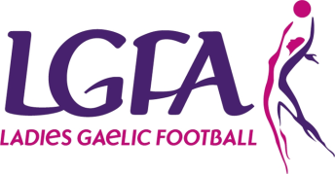
Easter Keeper Camps

Application Form

First Name |  | Surname
Date of Birth |  | Club Registered With
Mobile Number (Parent/Guardian if Under 18)
Email Address (Parent/Guardian if Under 18)
Emergency Contact Name
Emergency Contact Number
Goalkeeping Experience (if any)

Venue
Tuesday 11th April Maynooth University Registration 10.30am - Finish 5pm
Thursday 20th April University Of Limerick Registration 10.30am - Finish 5pm

Medical Conditions
Please indicate any medical condition or special needs we ought to be aware of:

Food Allergies
Please indicate any food allergies we should be aware of:

Fee
Each application must be accompanied by the non-refundable €35 fee to confirm your place and sent to:
Lyn Savage, National Development Officer, LGFA, Croke Park, Dublin 3 or email lyn.savage@lgfa.ie
Cheque: (made payable to Ladies Gaelic Football Association)
Credit Card:
Card Number: ____________________________________
Expiry Date: _____________ Sec Code: ___________

Signature (Parent/Guardian if U18): ______________________ Date: ______________
Please note participants must be registered playing members of LGFA

