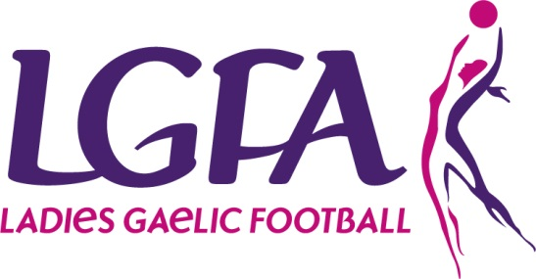
LGFA Inter-firms Blitz Competition
1 day blitz
Companies should attempt to conduct some form of training prior to the blitz. We would recommend for companies to meet up at least 4 times prior to the blitz for a 1 hour coaching session - this will help with team cohesion, preparation of the blitz day etc. The LGFA will provide samples sessions for companies to conduct.
Venue: Naomh Mearnog, Portmarnock, Dublin
Date:: Saturday 15th July 2017
Timings: 11 – 4 p.m.
7-a-side/ panels of 12
20 minute games
Semi-finals & Final (dependent on number of teams – there may be a Cup and a Shield Final)
Please note photography and video will be taken on the day by authorised LGFA personnel and will be used for the purpose of publicising and promoting the event. Please inform the blitz coordinator prior to the blitz if you or any of your players have any concerns regarding same.
Costings
€60 per team (€5 per player)
Playing Conditions
- Full rules of LGFA apply
- All players are exempt from the Injury Fund – players are advised to invest in their own insurance cover. The LGFA will accept no responsibility for injury caused to players during the course of the blitz
- Where companies wish to enter more than one team, they must supply a team list for each team. Players will only be permitted to play with one team for the duration of the competition.
- Disciplinary matters
  - If a player is red carded during the course of the blitz, she will not be eligible to participate in the remainder of the blitz.
- Player Eligibility
  - Firms shall not be allowed play the following players
    - Players who come to a firm solely for training purposes for a period of three months or less and are not employed, under the same terms as permanent or temporary employees
    - Prison officers or garda recruits, while training, can only play with a firm in the area they are based while training
    - A player who has not yet commenced their employment with that firm
    - Guest players will not be permitted
    - Contractors are not permitted to play – players must be employed directly by the company entering the team

