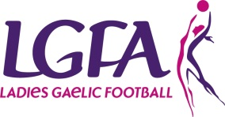
Coaching With Performance Analysis Workshop

This is a football focused workshop aligned to the coaching process demonstrating how analysis can be used to improve observation, communication and learning, for both coach and performer.
This workshop is specifically designed for Managers, Coaches or Team Performance Analysts currently involved with county teams at Under 14, 16, 18, 21 or Adult level only.

County: __________________________________

Total Number of Tickets: __________

First attendee ticket is €40 and €25 for additional mentors from your county thereafter. Please note places are limited.

 | Attendee Name | Team Involved With | Email Address | Phone Number | Ticket Cost
1 |  |  |  |  | €40
2 |  |  |  |  | €25
3 |  |  |  |  | €25
4 |  |  |  |  | €25
5 |  |  |  |  | €25
 |  |  |  | TOTAL PAYMENT

Payment details

Cheque: Credit Card:
(made payable to Ladies Gaelic Football Association)
Card Number: ____________________________________
Expiry Date: ________ Sec Code: _______

Please submit to: Lyn Savage, LGFA, Croke Park, Dublin 3 or email lyn.savage@lgfa.ie by Monday 18th December

Please note we cannot reserve places without payment and fees are non-refundable from 1st January

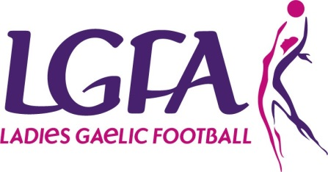

Coaching with Performance Analysis Workshop - Knowledge-Share

Date: Sunday 7th January 2018
Venue: Cusack Suite, Level 5, Cusack Stand, Croke Park

A football focused workshop aligned to the coaching process demonstrating how analysis can be used to improve observation, communication and learning, for both coach and performer.

Success isn’t always what we see! And how we learn is changing…

Research shows that coaches can only recall about 30% of live performance factors, add to this emotional or subjective bias and we miss a lot of what actually happens in the game. Through the workshop we will show how analysis can be stitched into the coaching process as a teaching and learning tool that uncovers the less obvious and also helps coaches show players what they mean (visual communication), and players themselves to reflect on their own performance.

The workshop will address a number of themes in practical terms linked to coaching and analysis. These themes are adaptable to fit your own coaching objectives and team level for observation, analysis, interpretation, communication and learning. This will include what is meant by a ‘player-centred approach’ both for a coach and player, and how performance analysis supports this as a process, enabling the athlete to self-discover, and transition from directive one-way communication to multi-way communication between athletes and coaches.

Workshop Delivery:

• Presentations with case studies combing theory and practice
• Panel of speakers sharing their experiences in their words via Q&A (player, coach and coach/analyst)
• Interactive group work and practical tasks

Est. timeframe

• 10.00 - 10.25: tea/coffee & registration
• 10.25 - 10.30: welcome & intro
• 10.30 - 12.30: part 1
• 12.30 - 13.15: lunch
• 13.15 - 14.45: part 2
• 14.45 - 15.00: recap & close
• Attendees will receive an online takeaway pack as a recap

