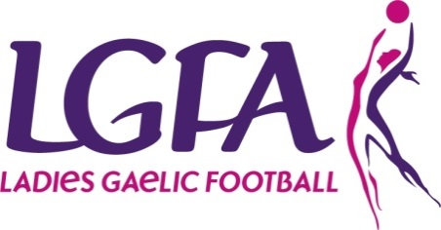

Permission to play ADULT football application form
In accordance to rule 139 of the official guide
Fill Section 1 (below) and Section 2 (overleaf), send to the County Secretary and copy to Central Council. (Head Office will record the date received).
County Secretary fills Section 3 and sends the complete form to Provincial Council and Central Council.

Section 1: To be filled out by player
Name: D.O.B.
Contact Number: Email:

Address:

Current Club:

Grade of Current Club: Junior Intermediate Senior

Club you seek permission to play:

Grade of that club: Junior Intermediate Senior

Reasons for permission to play request:
Have you played club/county in last 3 years, if so state team, grade and age group:

Number of club matches played last season: League: Championship:
List previous permission to play if any (include club, grade and year):

Signature of applicant: ____________________________
Signature of parent/guardian (if player u18): __________________________
Date: _____/_____/_______
Section 2: To be completed by home club secretary/registrar
No. of players/mentors registered in your home club:
Players: Adult U-18 U-16 U-14 U-12

Mentors:

Your current Club’s Status:
Juvenile Only Adult Only Juvenile and Adult

Adjoining clubs:

Names of any additional players seeking permission to play outside your club:

Are there other clubs within your Club CCA? If so please list them

Club secretary/registrar signature: ___________________________
Contact number: _________________________________
Date: ____/_____/______
Fill Section 1 (below) and Section 2 (overleaf), send to the County Secretary and copy to Central Council. (Head Office will record the date received).
County Secretary fills Section 3 and sends the complete form to Provincial Council and Central Council.

Section 3: To be completed by County board
Permission: Granted / Refused Result of Vote (if vote was taken)
For Against
Reason for decision:

Any other relevant information:

Date received by the County Board: ___________________
Date of county board meeting: _____/_____/______
County Secretary Signature: ______________________________
Please ensure that all sections are completed accurately and the numbers provided have been verified by the County Board.
Incomplete forms will be refused and returned
Completed applications must be emailed to the relevant Provincial Council and also to Central Council via the contact details listed below:
Provincial Council Contact Information
Province | Secretary | Administrator
Connacht | secretary.connacht@lgfa.ie | admin.connacht@lgfa.ie
Leinster | secretary.leinster@lgfa.ie | admin.leinster@lgfa.ie
Munster | secretary.munster@lgfa.ie | admin.munster@lgfa.ie
Ulster | secretary.ulster@lgfa.ie | admin.ulster@lgfa.ie

Central Council Contact Information
Email | info@lgfa.ie

