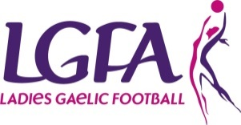
County Cultural and Language Officer

Role Description
The role of the County Cultural and Language Officer is to provide advice to the County/Clubs officers in supporting the National Language and Culture.

Reports/accountable to
- Coiste Contae

Responsibilities
- Act as Cathaoirleach of the Coiste Cultúr agus Teanga Contae (County Culture and Language subcommittee if in place) and to be a member of the County Executive
- Provide a service/input for County Publications/Programmes and Medals and Trophies
- Liaise with other language and cultural groups within the County
- Liaise with Clubs regarding Cúrsaí Gaeilge
- Encourage the use of bi-lingual materials (signs etc...) within the County and in Clubs.
- Administer County Gaeltacht Scholarships Schemes

SKILLS | KNOWLEDGE
- Have good written and spoken knowledge of the Irish Language (Gaeilge)  - Have good communication skills  - Ability to Delegate tasks  - Have good organisational skills  - Be IT literate | - Eolas mhaith ar an teanga dúchais agus ar chultúr traidisiúnta na tíre/ A good knowledge of the native language and the traditional culture of the country

OTHER REQUIREMENTS
- Have time to do the job
- Have a genuine interest in the Association
- Have a genuine interest in the Irish language and culture
- Be of good standing in the community

