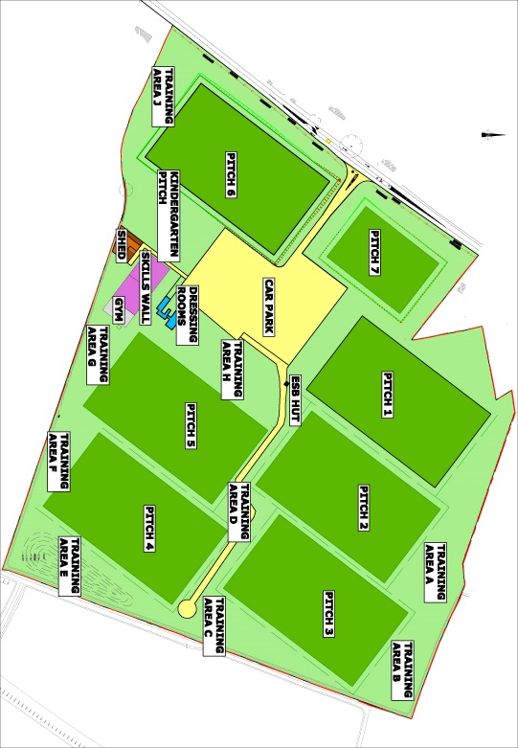

Division 2 A

**Division 1 B**

**Division 1 A**

**Division 3 B**

**Division 2 B**

**Warm Up Area**

Warm Up Area

**Pitch 6**

**Division 3 A**

**Pitch 5**

**Warm Up Area**

**Reception**

**Dressing Room**

**Shop**

**Warm Up Pitch**

**Pitch 4**

**Pitch 1**

**Pitch 3**

**Pitch 2**