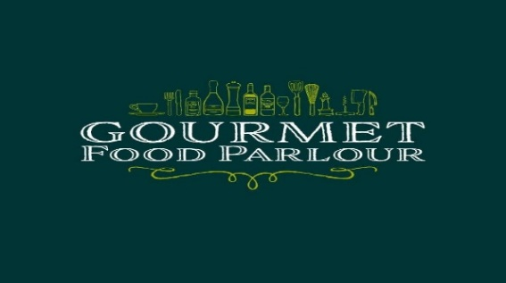
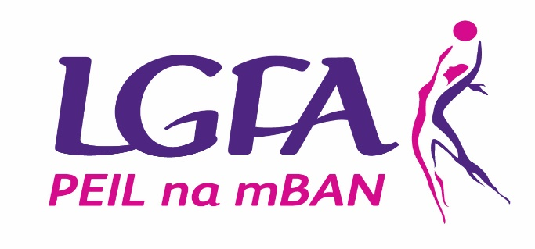
Gourmet Food Parlour LGFA HEC League Divisions 2018/19
Group A | Group B
DCU | AIT
MU | NUIG
QUB | UCC
UCD | UL
Curran Cup 2018 (Division 2)
Group A | Group B
DCU2 | IT Sligo
IT Carlow | MICL
UCD2 | UL2
UUJ | WIT
Quill Cup 2018 (Division 3)
Group A | Group B
DCU3 | CIT
DIT | IT Tralee
St Marys Belfast | UCC2
TCD
Division 4 (2018)
Group A |  | Group B
A1 | A2 | GMIT Galway
IT Blanch | DCU4 | MICL2
RCSI | DKIT | NUIG2
UCD3 | LYIT | UL3
Division 5 (2018)
Group A | Group B | Group C
Marino | QUB2 | MU2
DCU5 | UU Coleraine | IT Sligo2
Cavan Inst | UUM | AIT2
IT Tallaght | UUJ2 | LIT
UCD4
Division 6 (2018)
Group A | Group B
Kerry CFE | NCI
GMIT Castlebar | Law
MICL Thurles | DCU6
Carlow CFE | TCD2
 | DIT2

