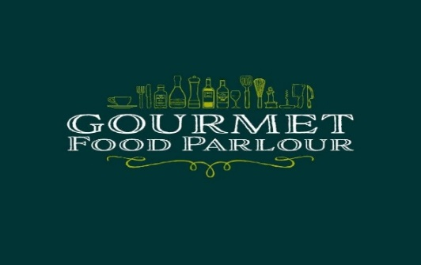

Gourmet Food Parlour Ladies Football HEC League Fixtures
for Week commencing Monday 8th October 2018
Division 1
Date | Time | Venue | Round
11 October 2018 | 7.45pm | UCD | 1 | UCD | v | DCU
11 October 2018 | 2.30pm | MU | 1 | MU | v | QUB
11 October 2018 | 2.30pm | NUIG | 1 | NUIG | v | AIT
10 October 2018 | 7.30pm | UL | 1 | UL | v | UCC
Division 2
Date | Time | Venue | Round
11 October 2018 | 18.15pm | UCD2 | 1 | UCD2 | v | DCU2
11 October 2018 | 2.30pm | UUJ | 1 | UUJ | v | IT Carlow
11 October 2018 | 2.30pm | IT Sligo | 1 | IT Sligo | v | UL2
11 October 2018 | 7.30pm | WIT | 1 | WIT | v | MICL
Division 3
10 October 2018 | 2.30pm | DIT | 1 | DIT | v | TCD
10 October 2018 | 2.30pm | DCU3 | 1 | DCU3 | v | St Marys Belfast
10 October 2018 | 2.30pm | UCC2 | 1 | UCC2 | v | CIT
Division 4
10 October 2018 | 2.30pm | Halfway | 1 | DCU4 | v | LYIT
09 October 2018 | 7.00pm | DKIT | 1 | DKIT | v | RCSI
10 October 2018 | 2.30pm | UCD3 | 1 | UCD3 | v | IT Blanch
10 October 2018 | 2.30pm | UL3 | 1 | UL3 | v | MICL2
10 October 2018 | 2.30pm | GMIT Galway | 1 | GMIT Galway | v | NUIG2
Division 5
10 October 2018 | 2.30pm | QUB2 | 1 | QUB2 | v | UUM
10 October 2018 | 2.30pm | UUC | 1 | UUC | v | UUJ2
10 October 2018 | 2.30pm | Marino | 1 | Marino | v | DCU5
10 October 2018 | 2.30pm | Cavan Inst | 1 | Cavan Inst | v | IT Tallaght
10 October 2018 | 2.30pm | MU2 | 1 | MU2 | v | AIT2
10 October 2018 | 2.30pm | LIT | 1 | LIT | v | IT Sligo2
Division 6
10 October 2018 | 2.30pm | Kerry CFE | 1 | Kerry CFE | v | MICL Thurles
10 October 2018 | 2.30pm | GMIT Castlebar | 1 | GMIT Castlebar | v | Carlow CFE
10 October 2018 | 2.30pm | Law | 1 | Law | v | NCI
10 October 2018 | 2.30pm | DCU6 | 1 | DCU6 | v | TCD2
#GFPColleges

