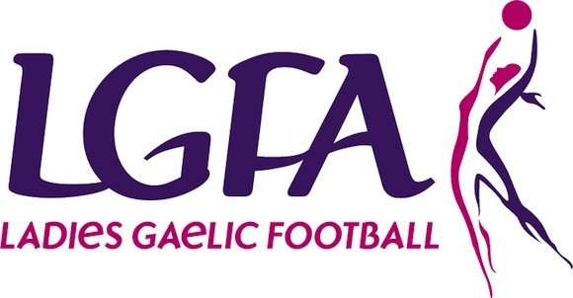
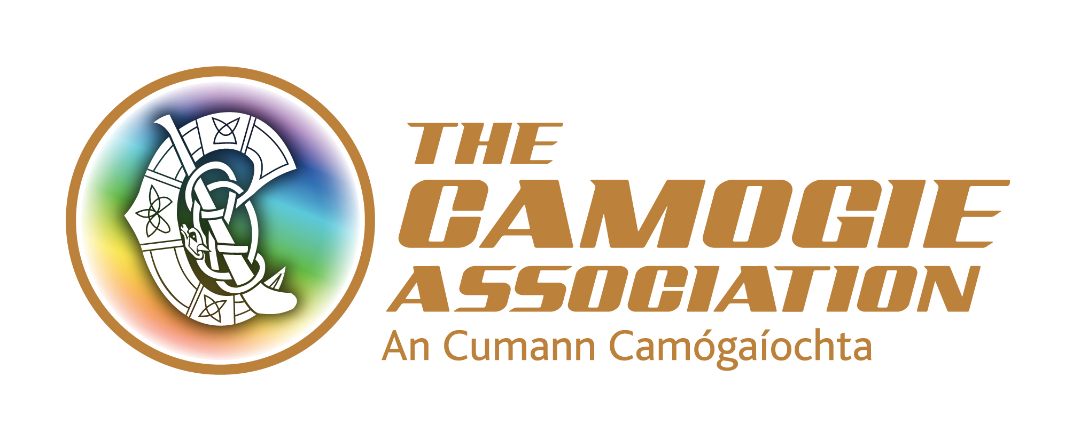


INVITATION TO TENDER

DEVELOPMENT OF AN ONLINE PLATFORM FOR THE GOVERNMENT GRANT SUPPORT SCHEME

Section A: Introduction
The Ladies Gaelic Football and Camogie Government Grant Support Scheme was launched in January 2017. The purpose of the Scheme is to provide funding to support an enhanced playing and training environment for intercounty camogie players and ladies footballers. The Scheme funded by the government and administered through Sport Ireland, is an indicator of the recognition that exists at national level for the contribution of these athletes to their sport and their commitment to play the game at the highest level possible. The Scheme equated to a grant of one million Euro, distributed equally in 2017 and 2018 to all highest-grade county teams participating in National League and/or All Ireland championship competitions. The Scheme has been extended into 2019 when at least 50 grants will be processed and issued to counties.

The Scheme has three primary objectives; namely to assist with:
- Injury Prevention and Medical Cover: pre-habilitation activity such as movement screening and mobility training and/or the presence of appropriate medical cover at games and training
- Maximising Player and Team Performance: enhanced and consistent access and delivery of activities, such as strength and conditioning programmes, specialised coaching, performance analysis, performance nutrition advice and psychological preparation
- Access to Training Facilities: access to specialist training facilities, such as all weather, indoor and floodlit facilities, and gym use.

A Scheme Implementation Group (SIG), comprised of an independent chairperson, a scheme administrator and two representatives each from the Ladies Gaelic Football Association, the Camogie Association and the Women’s Gaelic Players Association, oversee the implementation of the Scheme This is replicated at county level where administrators (county boards), management and players must work collaboratively to plan and report on agreed initiatives that are eligible for submission for funding under the Scheme.
The SIG reports to a higher-level Steering Group that includes representatives from the Department of Transport, Tourism and Sport and Sport Ireland.

Section B: Remit of Tender
The current tender is to establish an online system to replace the current hard/soft copy (mainly email) submission and management processes used to administer the Scheme. The main objectives of the online platform are:

a) To allow counties to submit their funding applications through an online portal
b) To ensure full transparency of submissions and claims between all representative groups (county boards, managers, players)
c) To put processes in place to allow counties to upload documentation for submission in relation to their grant claims
d) To support the Scheme Implementation Group to ensure a user-friendly application to approve claims
e) To support the overall financial management of the grants for counties and the SIG
f) To support the financial checking systems associated with the administration of the grants.
g) To provide a centralised information and support system for the Scheme

The online portal should include but is not limited to the following:

- A landing page that provides a description of the Scheme along with relevant submission and claim information, training videos, case studies and FAQs
- Access area for each county with four sign ins available; one with full administration full access, and one with more limited access (treasurer – to allow to upload receipts etc.) and two to digitally sign off on agreed documents
- An online application form for the grant scheme and there will need to be an auto upload option for the 2019 application as these will be already in use)
- Ability to upload documents for submissions and claims; for example, receipts, qualification records
- Functionality to change application submission which in turn notifies the government grant scheme administrator
- Functionality to allow for approval of uploaded submissions by the grant administrator
- A dashboard for the grant scheme administrator to access all submissions
- Functionality to generate reports and statistics, update financial information and archive previous documentation
- Ability to administer surveys

Note: These tasks represent the nature of activities to be undertaken as part of the service, but that it is not an exhaustive list of requirements.

Section C. Submission of Tenders
Tenderers may be individuals, organisations or consortiums.
The methodology proposed by tenderers must take account of a participatory process.

The full tender submission should not exceed five A4 pages in length and must detail:
- The approach to meeting the requirements listed in Section B above, detailing systems, processes and data storage.
- Outline proposed timelines – the Scheme Implementation Group’s preferred option is to commence immediately after the award of the contract, and to have the system in place in early 2019;
- Specify the proposed level of engagement with the scheme implementation group and the proposed work schedule.
- Provide details of a designated lead contact, details of team members (together with information on their experience relevant to the assignment) where relevant and contingency details should circumstances require a change in personnel
- Pricing Quote - Please provide pricing quote (incl VAT) for proposed services as per Section B above. The price quoted should be all-inclusive i.e. it should include all costs related to the project (including travel and any other relevant or ancillary expenses).

The tender submission must demonstrate:
- Technical and professional ability to meet the tender requirements, including at least two examples of relevant work completed within the last 3 years;
- Quality assurance standards including procedures for maintaining data protection and security of information;
- Capacity to complete work in the time frame detailed below.
- How the system will be reviewed, evaluated, changed and updated and the ongoing IT support required.

Timeframe and Budget

The timeframe for completion of the project is end February 2019, commencing in January 2019 on award of contract.

Section D: Award Criteria
- Compliance with tender requirements outlined in Section B & C above 30%
- Relevant qualifications of person(s) working on the project e.g. web and online platform design 10%
- Relevant experience of persons involved in design and implementation of the system 15%
- Demonstrated merit/quality of proposed approach 15%
- Total Cost 30%

The Tender Evaluation Panel may shortlist or meet tenderers at their discretion. The costs of attending such a meeting will be borne by the tenderer. The completion of a tender submission may not automatically guarantee that the project will go ahead as this is at the discretion of the Tender Evaluation Panel.

The Tender Evaluation Panel is not obliged to accept the cheapest quotation. All tenderers will be advised in writing of the final decision. All proposals will remain strictly confidential.

Conflict of Interest
The tenderer should declare if any personnel are proposed to work on this evaluation, if awarded, may have a conflict of interest and provide details of same. Should there be any conflict of interests identified by the tenderer or their personnel all details must be provided to the Tender Evaluation Panel at the time of application. In the event of any such conflict or potential conflict, the Tender Evaluation Panel may at its absolute discretion decide on the appropriate course of action and the decision of the Tender Evaluation Panel will be final and binding in this regard. A conflict of interest may include any factor, whether arising through personal interest, current or prospective contractual obligations or any other activity or association, which could prejudice the tenderer or its agents in the delivery, of the services required under the contract.

Section E: Intellectual and Property Rights
The Camogie Association, Ladies Gaelic Football Association and the Women’s Gaelic Players Association will jointly and severally own the data and outcomes resulting from the online system. Any promotion of the completed system or working relationship is subject to agreement from each organisation through the Scheme Implementation Group.

Section F: Management of Project
The project will be managed by the Scheme Implementation Group, with oversight from the higher-level Steering Group. The project manager will work closely with the Scheme Administrator and will report to the Group overall.

Section G: Deadline for Submission
All applications must be received by 5pm on 3rd December 2018 by emailing your completed proposal to intercountyfunding@gmail.com. Applications will not be accepted or considered after this date and time.

Section H: Further Information
A copy of the Scheme descriptor is available on request from intercountyfunding@gmail.com

