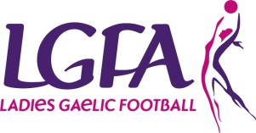
Female Liaison Officer
Role Description
Every team must appoint a female liaison officer and it is essential that the person selected has the required skills for the role as they are a key link between management teams, players and county executives.

Reports/accountable to
County Committee

Responsibilities
- Female presence on the Management Team
- Liaise between the County Team (management and players) and the County Board
- Liaise between the players and the management team
- Ensure training and training methods are appropriate for females and target age group
- Ensure Code of Best Practice is adhered to i.e. Code of Conducts, Travel Permission Forms, Parental Consent Forms
- Act as an advisory resource for players
- Organise logistics where required
- Monitor drop out from County Teams

SKILLS | KNOWLEDGE
- Excellent planning, organisational, interpersonal and communication skills  - Ability to BUILD TRUST  - Impartiality, fairness and the ability to respect confidentially | - Have sound knowledge of LGFA and team guidelines  - Have experience of people management

OTHER REQUIREMENTS
- Have time to do the job
- Have a genuine interest in the players
- Be of good standing in the community

