

**PERSONAL DATA BREACH REPORT FORM**

**If you discover a personal data breach, please notify your Data Protection Officerimmediately. Please complete this form and return it to the Data Protection Officer** [**paula.prunty@lgfa.ie**](mailto:paula.prunty@lgfa.ie) **as soon as possible.**

***In accordance the Data Protection Legislation, following the discovery of a Data Breach the Data Controller (LGFA) has 72 in which to inform the Data Protection Commissioner. It is therefore imperative that each incident is reported immediately to afford the time to review.***

***To be completed by whom so ever discovers the breach***

|  |  |  |
| --- | --- | --- |
| **1** | **Date(s) of Breach:** |  |
| **2** | **Date Incident was discovered:** |  |
| **3** | **Name & Contact of Person Reporting Incident:** | **Eg Joe Bloggs,** |
| **4** | **Name of Contact of Person Discovering Breach:** | **If different** |

|  |  |
| --- | --- |
| **Brief Description of Personal Data Breach:** |  |
| **Number of Data Subjects affected – if known** |  |
| **Measures taken since Breach discovery:** |  |

***Signed: ………………………………………… Date: …./…./…….. Sent to IMU: …./…./…….***

***For DPO use only:***

|  |  |  |
| --- | --- | --- |
| **1** | Category of Personal Data: |  |
| **2** | Category of Data Subject Effected: | **Staff / Public** |
| **3** | Impact Assessment Finding: |  |
| **4** | GDPR for Sport Notified | **Yes / No** |
| **4** | Immediate measures enacted: |  |
| **4** | Data Protection Commissioner Notified | **Yes / No** |
| **5** | Policy Reviewed / Amended |  |

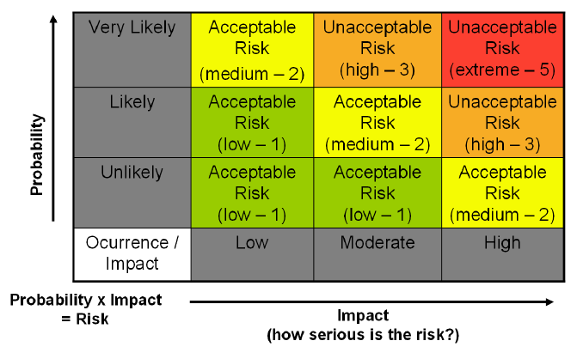

***Signed DPO:…………………………………………………… Date: …../…../………….***

***Signed GDPR for Sport:………………………………… Date: …./….../…..…….***

***Investigation Report Attached***