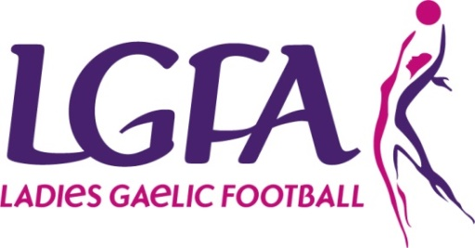
2019 Interfirms Blitz
ENTRY FORM

Please complete Entry form and return with appropriate Entry Fee to Shauna Mc Nutt, National Development Officer by 24th April 2018 email developmentsupport@lgfa.ie

Please Note – All sections must be completed

Please tick blitz entering: Competition Recreational
(Enter number if more than 1 team)

Company Name:

County:

Team Contact Name:
Phone: (Mobile):

Email:
Jersey/T-Shirt Colours:

(7aside/max panel 12) | Competition | Recreational | Total No. of Teams entering | Total Cost Due
No of teams Entering |  |  | @ 60euro per team | =
Total Number of players
Payment Details
Payment Type: | Cash | Cheque | Credit Card | Postal Order
(Please ensure all Cheques/Postal Orders are made payable to the LGFA)
Credit Card Details:

Card Type ___________________ Name on Card _______________________________________

Card Number__________________________________
Expiry Date: (month/year)_____/____ | Security Code (last 3 digits on back of card) _________
