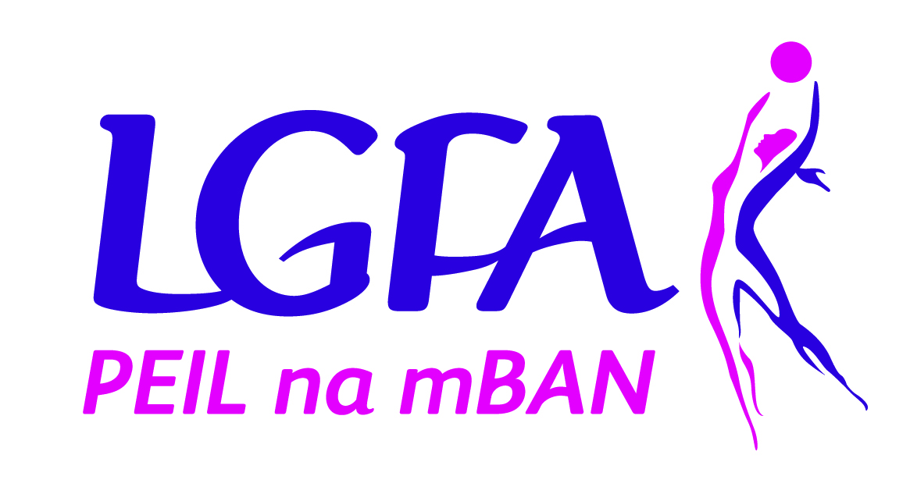

Provincial Academy
Referee Programme Application Form
2019

LGFA Provincial Academy Referee Programme

Application Form

To begin the process of becoming a LGFA Provincial Academy Referee applicants must complete this application form and return it to your county secretary (secretary.county@lgfa.ie). All candidates must be signed off by their county executive who will then forward the applications to Clare Dowdall, National Development Officer, clare.dowdall@lgfa.ie to register your initial interest in becoming an Academy referee.

Please Note – All sections must be completed.

NAME: ____________________________________

ADDRESS: ____________________________________

____________________________________

PHONE NUMBER: _______________________________

EMAIL: _______________________________

AGE: _______________________________

Name of club attached to: _______________________________

Name of county attached to: _______________________________

Number of Years Refereeing _______________________________________

Highest Grade You Have Refereed at________________________________

Please indicate why you would like to become an Academy Referee?

Please return your application:

Before 22nd April 2019 to your county secretary using the email@

secretary.(Yourcounty)@lgfa.ie

Any applications received after 26th April will not be considered for the training programme this year.

Candidate Signed: _________________________________

Date: ________________________________

To be completed by county secretary.

Why have your county nominated this participant to get involved in the Provincial Referee Academy Programme?

County Executive Signed: _________________________________

Date: ________________________________

County Secretary to forward this application to:

Clare Dowdall, National Development Officer, clare.dowdall@lgfa.ie by Friday 26th April

LGFA Provincial Referee Academy Programme
Programme Details
- Referee academy in all four provinces for up and coming referees
- Age 18-25 years old
- Not on Provincial or National panel
- Candidates must apply through county executive to get sign off
- County executive to nominate at two candidates per county – at least one must be female
- 18 month programme minimum
- Candidates must pass a rules test and fitness assessment prior to entry to the Academy during introduction night
- Candidates must be committed to attend all Workshops which will be held
- Candidates should commit to assist at or contribute to refereeing seminars / workshops upon completion of the Academy

Time Frame
Session 1: Theory (May)
Theory - introduction to programme and fitness testing, goal setting
Session 2: Practical Gaelic4Mothers provincial blitz June/July 2019
Session 3: Theory (August 19th -30th August)
Rules, positioning, and videoing
Session 4: Practical All Ireland 7s
Referee assessment - 14th September 2019
Session 5: Practical (5th October) National Gaelic4Mothers&Others Blitz
(Invite to provincial referee hubs for the winter)
Session 6: Theory (18th- 29th November)
Shared learning, role plays and basic psychology
Session 7: Practical (February- March 2020) Linesperson for a National League game in their province with a national referee
Session 8: Practical (April- May 2020) Referee at provincial Under 14 and development academy days
Session 9: Theory (July 2020)
Rule test, conflict, reflective learning, organise buddy system and 6 Month referee plan for all referees.
Session 10: Conclusion Theory (November 2020)
Wrap up, follow up and way forward

