

**Subject Access Request Procedure**

**Why we have a procedure?**

Individuals have a legal right to see information that the LGFA holds about them, subject to certain exemptions and unless there are compelling reasons not to do so. Requests for access to records are currently governed by the following legislation:

**General Data Protection Regulations**

Article 5 – principles relating to processing of personal data

**General Data Protection Regulations**

Article 12 – transparency, information, communication and modalities for the exercise of the rights of the data subject

**General Data Protection Regulations**

Article 15 *(See Appendix 1)*

**Data Protection Act (1988 – 2018)**

Section 60 Data Protection Act 2018 Exemptions *(See appendix 2)*

**Who does the procedure apply to?**

All staff are responsible for adhering to the timescales highlighted within this policy and aiding the Information Management Unit with access to requested information. LGFA has a legal obligation to respond for SAR’s within 1 month of receipt.

**When should the procedure be applied?**

The procedure should be applied for all requests of personal information.

**How to carry out this procedure**

Access to personal information is referred to as a Data Access Request. The following flow chart shows this process broken down into 6 stages.

**Stage 1 – Request Received**

Formal requests for access to records must be made in writing which can include email. LGFA does not require a formal application to be completed. However if the individual would prefer to complete an application form this can be provided (*see appendix 3*).

All formal requests are dealt with by the DPO.

If members ask for advice on applying for access, staff should advise them that they will need to:

* Put their request in writing (provide a copy of the application form where necessary)
* Provide the LGFA with any relevant information that is required to sufficiently confirm their identity (May include: PPS No, Staff ID number, copy of Passport/Drivers Licence/PPS Card)
* If the individual requires help to put the request in writing the staff member should aid the individual in either writing the request or completing the application form.

Where a request is received by a section directly it must be forwarded without delay to the DPO. The request will be assigned a reference and an acknowledgement sent to the requester by the DPO. The acknowledgement letter will confirm receipt of the request and outline the process.

**Stage 2 – Identity Checks**

The following individuals are able to apply for access to records:

* The Member
* The cmember’s representative, with the member’s consent
* A parent or guardian may apply for access on behalf of a child
* An Garda Síochána (Section 41(b))

N.B Requests on behalf of the deceased cannot be processed as GDPR does not apply

Appropriate ID should accompany the request to verify the requester’s identity. If not supplied the DPO will request same however, processing of the request should proceed in the interim - awaiting verification cannot be used as grounds to extend the legislative timeframe.

The following individuals are able to apply for access to employee records:

* The employee
* The employee’s representative with the individuals consent
* A person appointed by the Court
* An Garda Síochána

Identity checks are completed for the individual requesting their records by the DPO. Checks may also be made of the person’s representative to ensure they are able to receive the information. The following table shows what documentation or identity types are required for each requester type:

|  |  |  |  |  |
| --- | --- | --- | --- | --- |
| **Requester** | **Consent Required?** | **ID Documents Required** | **Any other documentation required** | **Additional Information** |
| The Data Subject (the person to whom the information refers) | No: as the request is made by the individual then further consent is not required | Photo ID document such as Passport/Driving Licence/PPS Card  Unique Identifier such as PPS Number/Staff ID number | No |  |
| Relatives, Carers, Next of Kin, patient personal representative | Yes (where applicable) | Photo ID document such as Passport/Driving Licence/PPS Card  Confirmation to show relationship with requester, for example the requesters birth certificate showing parents details |  |  |
| Courts | Yes | N/A | Court Order (where consent is not obtained) | Staff should always seek advice from the DPO before releasing information. |
| An Garda Síochána | Yes |  | Request for information must be signed by a Superintendent/Inspector | Section 41(b) Data Protection Act 2018 |
| Solicitors | Yes | Photo ID document such as Passport/Driving Licence/PPS Card  Unique Identifier such as PPS Number/Staff ID number | Signed consent (authority) form completed by the requester (or their representative) from solicitors |  |
| Third Parties (other organisations not listed) | Yes | Photo ID document such as Passport/Driving Licence/PPS Card  Unique Identifier such as PPS Number/Staff ID number | Consent is required to provide information to third parties. Where the requester is unable to give consent a relative, carer etc. is able to do this on their behalf. |  |

**Stage 3 – Record(s) Located**

Following acknowledgement the DPO will forward the request to all departments/sections it deems may hold records. Each section should then carry out a review to identify all records relating to the requester. If a section finds they do not hold any records they should advise the DPO accordingly.

**Stage 4 – Exemption Review**

Once all records have been gathered they should be reviewed to ascertain if exemptions apply. If staff wish to apply exemptions they must contact the DPO for assistance. Each decision to rely on an exemption under S60 of the Data Protection Act 2018 must be documented.

**Stage 5 – Copy Record (s)**

Once records have been identified and reviewed for exemptions they should be collated and copied/downloaded in the form of access requested by the client.

**Stage 6 – Release Information**

Records should be released to the requester via the form of access requested ensuring that they arrive within the legislative timeframe (within 1 month of request).

Please note, if a requester seeks access via email, records should not be released as part of the email body or as a normal email attachment. The records should be placed in a winzip file and the password sent to the requester separately. See *appendix 4* for further information on this process.

Appendix 1 – Article 15 GDPR

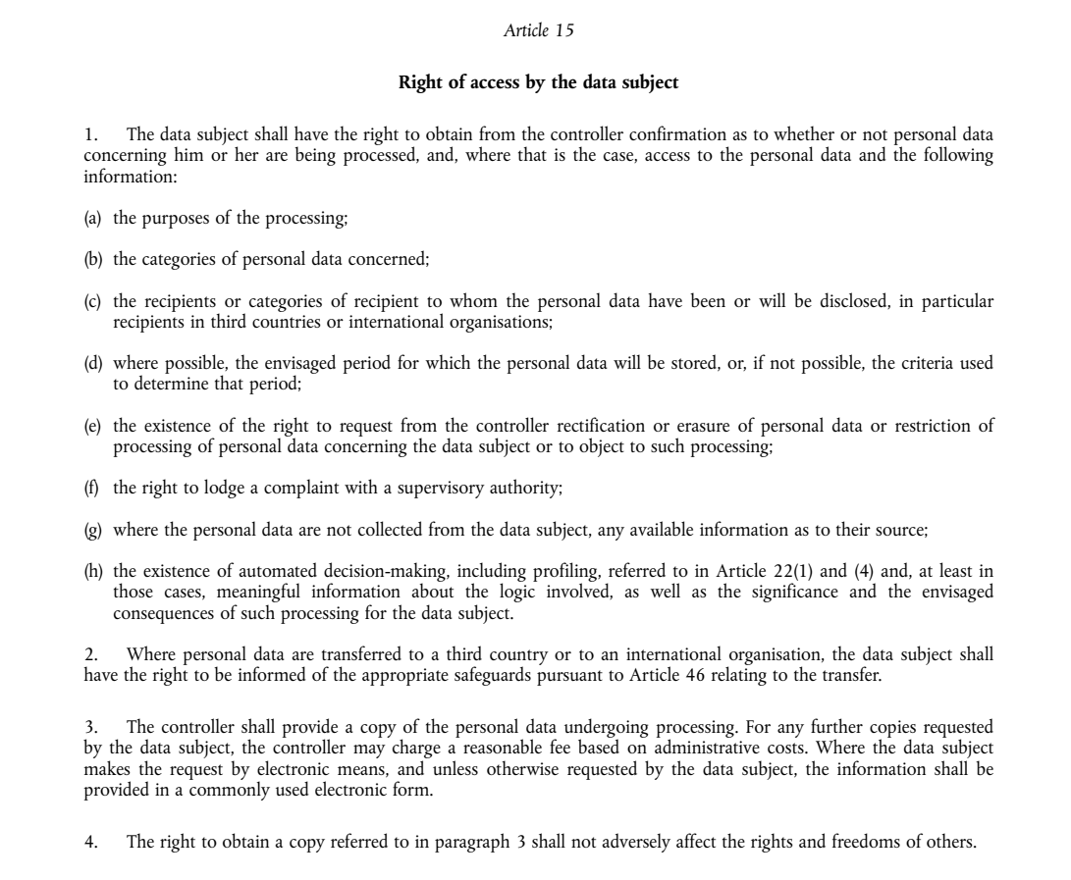

Appendix 2 –Section 60 Data Protection Act 2018

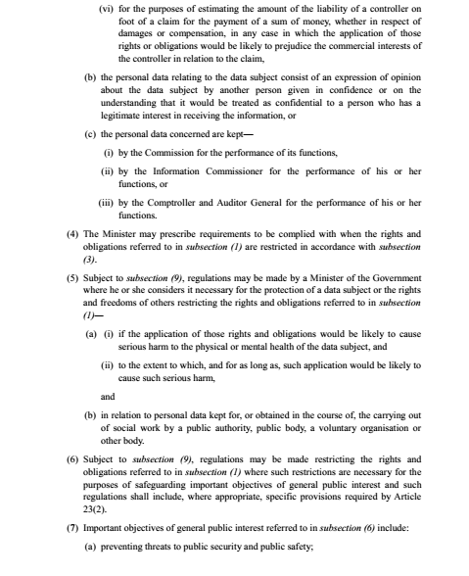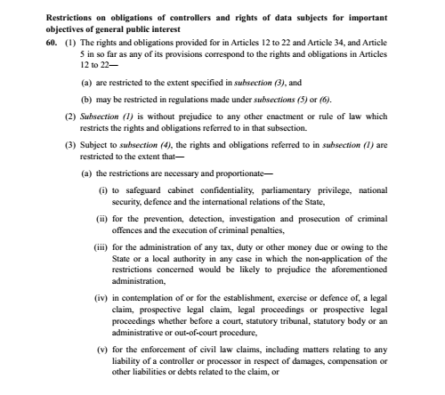

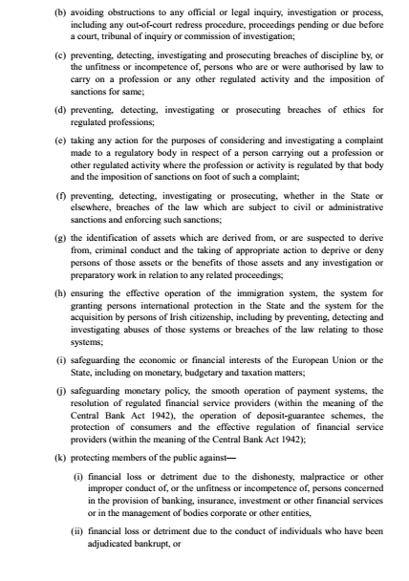

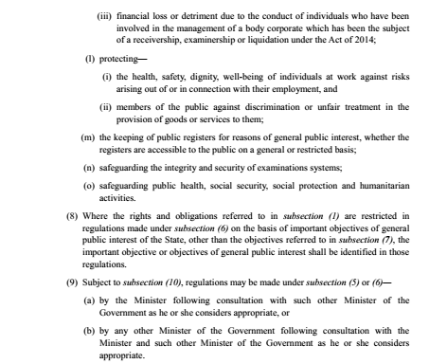

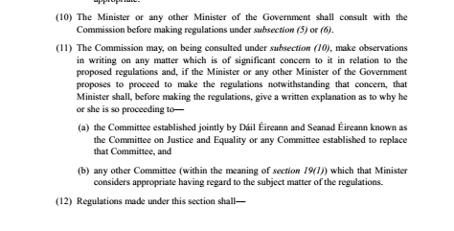

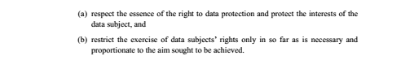

Appendix 3 Data Access Request Form

|  |  |  |  |  |  |
| --- | --- | --- | --- | --- | --- |
| **Request Details** | |  | | | |
| Full Name | |  | | | |
| Date of Birth | |  | | | |
| PPS Number *(only required in cases where Housing records or DCC staff employment records are sought)* | | | | | |
| Address | |  | | | |
| **Information Required** (*Please select as appropriate)* | | | | | |
| I require: | | | | | |
| A copy of full records | |  |  | | |
|  | |  |  | | |
| To view full records | |  |  | | |
|  | |  |  | | |
| To have a copy of part of record | |  |  | | |
| (Please provide information on what you require) | | | | | |
| **Consent to release records** | | | | | |
| I confirm that I am the above person and consent to LGFA releasing the information to me as requested within this form. | | | | | |
| Print name:  Sign: Date: | | | | | |
| OR: I confirm that I am ……………………………………………………………………….. and I consent to  LGFA releasing the information requested within this form to:  ……………………………………………….. Relationship: ………………………………………….. | | | | | |
| Date: | | | | | |
| **Form of Access** *(Please select as appropriate)* | | | | | |
|  | | | | | |
| My preferred form of access is: | To receive photocopies by post | | |  |  |
|  |  | | |  | |
|  | To receive photocopies by hand | | |  |  |
|  |  | | |  | |
|  | To receive soft copy by email | | |  |  |
|  |  | | |  |  |

Requests for personal information must be accompanied by a copy of appropriate photo ID (Passport/Drivers Licence).

Once completed forward this form to:

Data Protection Officer,

Address

Address

Address

Or by email to paula.prunty@lgfa.ie

Appendix 3 – How to complete requests for Information