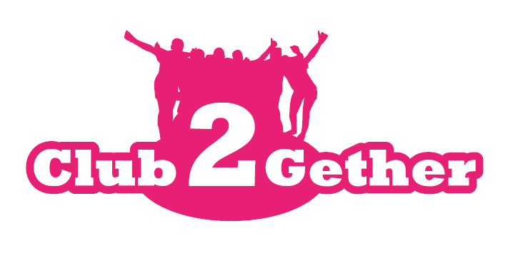
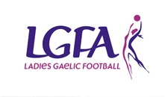
2019 Club2Gether
Application form

To register your Club’s interest and apply for the Club2Gether 2019 programme, please complete this application form and return it to: Niall Mulrine, National Development Officer by Friday 23rd August 2019

Please Note – All sections must be completed or the application will not be accepted
Club Name: ___________________________________________________________
County: ___________________________________________________________
Club contact for this application: ___________________________________________________________
Phone: (Home): ___________________ (Mobile): _____________________
Email: ___________________________________________________________
How long is your Ladies Football Club in existence? ___________________________________________
Age Group | Total number of registered members
Under 10
Under 12
Under 14
Under 16
Under 18
Adult
Non Players/Coaches
Gaelic4Mothers & Others

Officer | Please if currently in place
Chairperson
Secretary
Registrar
Treasurer
Children’s Officer
County Board Delegates
Details of any other officers

Please give the top 3 reasons why your Club should be selected for the Club2Gether Programme in 2019?

Please note that the Club2Gether Training will take place on the following dates and ALL members of your club executive must be available to attend. Clubs must complete all dates to fulfil programme.
Day 1
06th October 2019
Croke Park
Day 2
23rd November 2019
Croke Park
Day 3
8th February 2020
Croke Park
Day 4
7th March 2020
Croke Park

Signed: _________________________________ Date: _______________________________

Please submit by post to Niall Mulrine, LGFA, Croke Park, Dublin 3 or email Niall on niall.mulrine@lgfa.ie Contact: 0871631112

Please note that any applications received after the closing date (Friday 16th August 2019) will not be considered for the Club2Gether programme this year.

