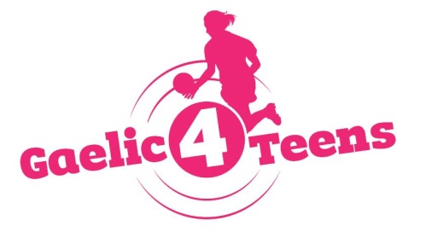
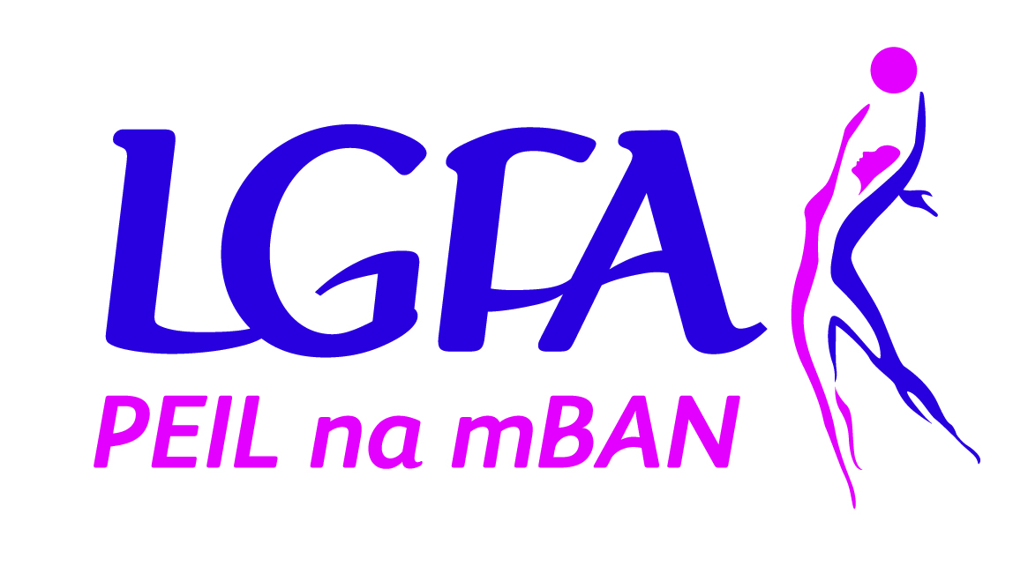

Application form

To register your Club’s interest and apply for the 2020 Gaelic4Teens programme, please complete this application form and return it to Shauna McNutt by email developmentsupport@lgfa.ie by Friday 22nd November 2019.

Please Note – All sections must be completed or the application will not be accepted
Club Name: ___________________________________________________________
County: ___________________________________________________________
Club contact for this application: ___________________________________________________________
Phone: (Home): ___________________ (Mobile): _____________________
Email: ___________________________________________________________
How long is your Ladies Football Club in existence? ___________________________________________

MEMBERSHIP FIGURES:
Age Group | Total number of registered members | Number of mentors currently involved with the team(s)
Under 8
Under 10
Under 12
Under 14
Under 16
Under 17
Under 18
Adult

CATCHMENT SCHOOL INFORMATION (fill in for both programmes)

Name of POST PRIMARY Schools in your area | Mixed/All Girls | Number of Girls aged 13 – 17 years | Catchment Clubs

REASONS TO BE SELECTED:
Please give the top 3 reasons why your Club should be selected to host 2020 Gaelic4Teens Programme…

RESOURCES
Please provide list of coaches that will be participating in this programme and indicate what age group they are involved with in the club

Name of  G4T Programme Co-Ordinator | Name of coaches  (where applicable to your club)
U13

U14

U15

U16

U17

KEY DATES:
Induction Evenings
- If selected for the programme, all club G4T Programme Co-ordinators (other personnel welcome also) must attend an induction evening prior to the commencement of the programme
- Induction Dates are as follows:

  - LEINSTER VENUE: TBC – Week commencing 3rd February
  - MUNSTER VENUE: TBC – Week commencing 3rd February
  - ULSTER VENUE: TBC – Week commencing 3rd February
  - CONNACHT VENUE: TBC – Week commencing 3rd February
Gaelic4Teens Programme Dates
- All coordinators and coaches involved in the programme must attend all dates associated with programme
- Location of Venues will be as based on clubs participating and will be as central as possible
Venue One | Venue Two
- Day One Saturday 15th February 2020  - Day Two Saturday 4th April 2020 | - Day One Sunday 16th February 2020  - Day Two Sunday 5th April 2020
Day Three National G4T Festival Day (Dublin) – Sunday 26th May 2020

Please tick which dates suit your club. Please note, we can only accommodate 16 clubs per venue but we will endeavour to facilitate where possible:
Venue One Venue Two

I confirm that:
- All information supplied in this application form is accurate
- I have read the G4T Overview Booklet in full and will fully comply with all terms and conditions associated with the roll out of the programme
- I understand all dates associated with the programme and understand mandatory attendance of club at same

Signed: _________________________________ Date: _______________________________

Please submit by post to Shauna McNutt, Ladies Gaelic Football Association, Croke Park, Dublin 3 or email Shauna at developmentsupport@lgfa.ie Tel:01 8363156

Please note that any applications received after the closing date (Friday 22nd Nov 2019) will not be considered for the Gaelic4Teens programme this year.

