[](http://www.google.ie/url?sa=i&rct=j&q=&esrc=s&source=images&cd=&cad=rja&uact=8&ved=2ahUKEwjvo5vd-ZbdAhUQe8AKHfl3Bl4QjRx6BAgBEAU&url=http://www.manyhandsonedream.ca/to-get-involved/&psig=AOvVaw0K-vgYKXLSKR32zxqLH0fm&ust=1535793195394545)[](https://www.sportireland.ie/)

**2019 European Week of Sport**

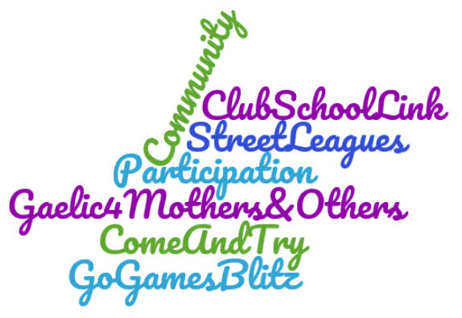**23rd – 30th September 2019**



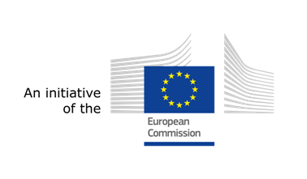**Register Your Event Now**

**with Sport Ireland!**