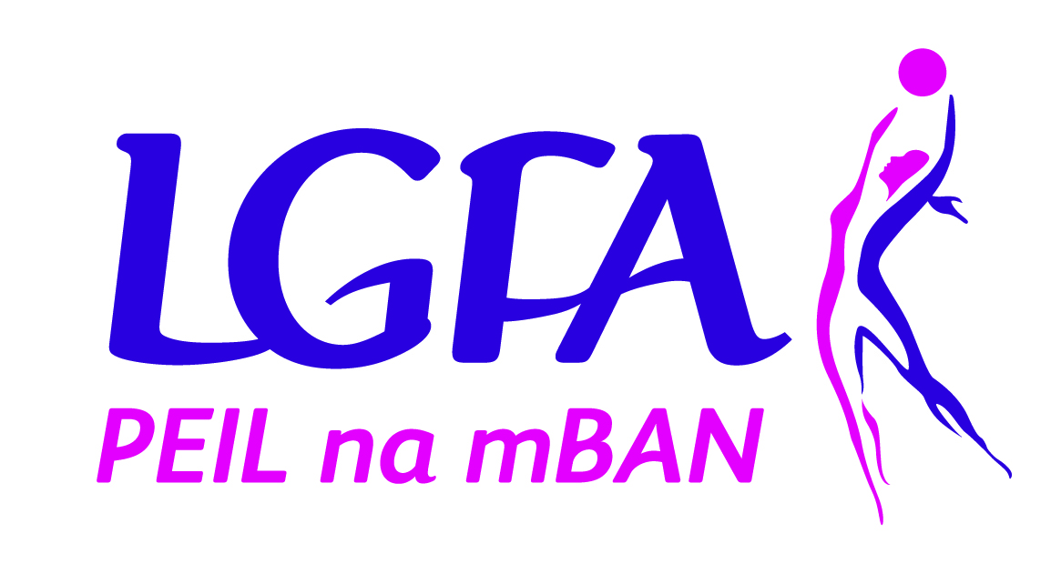
Ladies Gaelic Football Association
Underage Player Membership
Application Form

Name:_______________________________________________________________________

Address:_____________________________________________________________________

____________________________________________________________________________

Phone Number: _______________________________________________________________

Email (If available): ____________________________________________________________

Date of Birth: _________________________________________________________________

I hereby apply to:__________________________________________________ (“the club”) for membership of the club and membership of The Ladies Gaelic Football Association (“LGFA”).

Medical Information
Please outline any medical information (i.e. allergies, conditions, medication) which may impact on your child’s health, welfare or behaviour while participating in our activities.
______________________________________________________________________________
______________________________________________________________________________

- I consent to the processing of the personal medical data as outlined above for the purpose of administering medical assistance to my child if required.
- In the event of illness/injury, I give permission for medical treatment to be administered by a nominated first aider, or by suitably qualified medical practitioners.
- If I cannot be contacted and my child requires emergency hospital treatment, I authorise a qualified medical practitioner to provide emergency treatment or medication.
Signed_________________________ (Parent/Guardian) Date: __________________________

I subscribe to and undertake to further the aims and objectives of (Association) to abide by its Rules including the Code of Behaviour (Underage), which is available at: https://ladiesgaelic.ie/lgfa-hub/clubs/child-welfare-protection/code-of-behaviour/
Signed______________________________________ Date: _______________
Print Name: ____________________________________________________________________

Parent(s)/Guardian(s), on behalf of the above named:-

- We/I consent to the above application and to undertakings given by the Applicant.
- We/I understand that if I do not provide the Applicant’s Personal Data their Membership cannot be registered with the Club and the Association.
- We/I understand the personal data on this form will be used by the Club and the Association for the contractual purpose of registering (or re-registering) and maintaining the applicant’s membership and notification of Club activities such as matches, meetings and Club events.
- We/I understand that the Personal Data will be retained by the Club and the Association for such period as the applicant’s membership subsists and thereafter for archiving purposes to uphold the history of the sport.
- We/I understand that We/I can resign the applicant’s membership at anytime by writing to the Club or the Association.
- We/I understand that the applicant’s Personal Data will also be used for administrative purposes to maintain their membership including club and team administration, registrations, teamsheets, referee reports, disciplinary matters, injury reports, transfers, sanctions, permits and for statistical purposes.
- I understand that my contact information may be used to provide me with updates regarding legitimate club and LGFA activities.

Signed_________________________ (Parent/Guardian) Date: _______________
Print Name: ___________________________

I have read the important Data Protection information on the reverse of this form and have given my consent, by ticking the boxes and signing below, for my information to be used as follows: (Please tick as appropriate)
I am aware that my child’s photograph or video image may be taken whilst attending or participating in games or activities connected with the Club and LGFA and I consent to it being used by the Club and LGFA for items like match programmes, year books, match reports, event reports or on the Club/LGFA website or social media channels.

I understand that I can withdraw my consent at any time by writing to the [Club or my Association].
I understand my rights under Data Protection legislation, as outlined on later on this form

Signed: ________________________ (Parent/Guardian) Date: _____________

Print Name: _____________________________________________________________

IMPORTANT NOTIFICATION
The following privacy information is being provided to you as outlined in the General Data Protection Regulation. It is intended to inform you of how the personal information provided on this form will be used, by whom and for what purposes. If you are unclear on any aspect of this form, or want any further information, please contact the LGFA’s Data Protection Officer on 01 8363156 or dataprotection@lgfa.ie.

Privacy Notice:
The information requested in this form is for the sole purpose of processing your membership status. Staff from the Ladies Gaelic Football Association (LGFA) will process the information provided. The legal basis for processing this membership is for the performance of a contract. The legal basis for item (a) is "consent", items (b) - (f) is “contract” and item (g) is “legitimate interest”. The personal data will be stored on the LGFA Membership Database which is provided by Cumann Lúthchleas Gael for the purposes of processing and archiving only. A third party contract is in place between the LGFA and Cumann Luthchleas Gael to ensure the safe and legal processing of membership information. The information will be retained for the duration of your membership and for 100 years thereafter. The LGFA retain the right to extent this timeframe for archiving purposes. This is purely to secure the history of our game and to ensure that players time and dedication to our sport is always valued and never forgotten.

Who is the data controller?
The club and the LGFA are joint data controllers of the personal data and contact details for the club are as follows [Please insert: Club Name, Address, Phone / email].

Who is the Data Protection Officer for the LGFA and the club?
The LGFA Data Protection Officer is Paula Prunty. You can contact our Data Protection Officer at dataprotection@lgfa.ie or 01 8363156 if you have any questions or wish to make any request in relation to your personal data.

What is the purpose of processing my Personal Data?
The purpose for processing your personal data is that it is necessary for the performance of a contract in order to register and maintain your membership with the club and the LGFA. The purpose is also to keep you informed of club and LGFA events and activities as a member of the association.

Will anyone else receive a copy of my Personal Data?
Your personal data can be accessed only by appropriate members of the County boards, Provincial boards and National Administrative function. This will be done in accordance with our data protection policy only.
In the event of an injury claim, details of your claim which will include your personal data will be passed to the LGFA’s Injury Fund Administrator.

Where is your Personal Data stored?
Your data will be stored electronically on the LGFA membership database which is provided by Cumann Luthcleas Gael, Croke Park, Jones Road, Dublin 3.

How long will your Personal Data be stored for?
Your personal data will be held for as long as it is necessary and it has a purpose. This will vary depending on your club and their archiving needs. Please speak to your club for their specific membership retention policy. The LGFA retention period for membership data is outlined in the privacy notice above.

How can I obtain a copy of the Personal Data held by the Club/LGFA?
You have the right to request a copy of all of your personal data and can do so by contacting us.

What are my privacy rights relating to my Personal Data?
You have the right to request your personal data be updated, rectified, or deleted. You have the right to object to your personal data being processed - You can do so by contacting us.

Where can I get further information?
Further information regarding your rights can be obtained through the Office of the Data Protection Commissioner, 21 Fitzwilliam Square, Dublin 2. D02 RD28, or on the website www.dataprotection.ie

How do I make a complaint or report a breach?
Should you wish to make a complaint or report a breach under in relation to your personal data, you can do so by contacting your club representative or the LGFA Data Protection Officer at dataprotection@lgfa.ie or 01 8363156.

