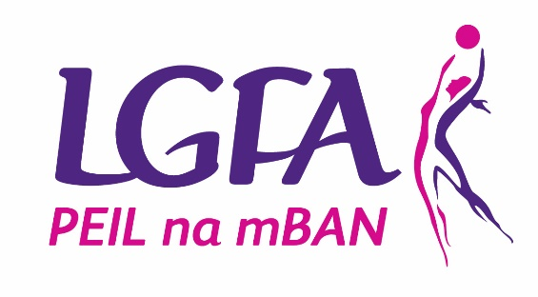

November 2019
Child Safeguarding Training
The LGFA and sister Associations continues to deliver high quality child safeguarding training to its members who are working in a role of responsibility with children and young people. Our training, which has been most favourably commented upon by external bodies, has been enhanced on an on-going basis so as to reflect the principles and content of our internal Codes, our Guidance and Safeguarding Policies and Rules.
Clubs may be aware that recent correspondence from Sport Ireland informed sports bodies that all training delivered must conform with the contents of the Sport Ireland training programmes.
Having met with Sport Ireland to discuss this issue we are happy to confirm that the Gaelic Games Associations will continue to deliver our child safeguarding workshops which are relevant to our needs and continue to comply with our legal requirements.
What does this now mean for our Clubs?
Should a person present themselves to a Club as a potential underage coach or be approached to take up such a role they will in accordance with our procedures have to be vetted, must complete a minimum coaching qualification and must also complete Gaelic Games Child Safeguarding Training. They must complete these requirements prior to commencing any role with Children in our Associations.
Following our discussions with Sport Ireland all that has changed is that if a person attends their initial safeguarding training (Safeguarding 1) with another sports organisation or with a Local Sports Partnership, we continue to recognise this training and the individual will then complete their child safeguarding training requirements by undertaking the new Gaelic Games on-line refresher training programme. (outlined below). The new on-line shall be completed by the individual within a time frame agreed with their Club. This agreement only applies to safeguarding training, as promoted by Sport Ireland, and is delivered by other sports bodies or LSPs. It does not apply to non-sports child safeguarding training.
Similar to all other underage coaches in any of the Gaelic Games Associations if a person attends their initial safeguarding training (Safeguarding 1) with another sports organisation or with a Local Sports Partnership and then completes the on-line programme they must still be vetted and must have a recognised coaching qualification.

3 New on-line child safeguarding programme available for LGFA coaches
As part of our joint approach to Child Safeguarding within the Gaelic Games Associations a new On-Line Child Safeguarding Programme was recently launched by the National Child Safeguarding Committee.
The On-Line Safeguarding Programme addresses a long-standing request that we introduce easy to access training as a repeat or refresher programme for those who have previously attended face to face child safeguarding training.
To participate and complete the on-line training a participant, i.e. a coach or a person working in a role of responsibility with or for children, must have fulfilled one of the following requirements:
1 They must within the last three years have attended a Gaelic Games Child Protection in Sport Awareness Workshop (Safeguarding 1) and they may then avail of the on-line programme in preference to attend another face to face repeat workshop, or
2 The participant, having attended a non-Gaelic Games Child Protection Safeguarding 1 Workshop with another Sports Association or a Local Sports Partnership (LSP), must then also undertake the new on-line Child Safeguarding Programme so as to familiarise themselves with our agreed safeguarding policies, procedures and in particular our joint Code of Behaviour (Underage) prior to commencing their work with children in any of the Gaelic Games Associations.
The new on-line training programme is available free of charge by accessing https://learning.gaa.ie/safeguarding

Within days of its launch the new on-line programme has been acclaimed as one of the most modern, inter active and up to date child safeguarding refresher programmes. It is easy to access and contains the necessary information whether it is completed as a refresher programme or a requirement for those who have attended previous child safeguarding training with another Sports Association (NGB) or an LSP. Each participant of the on-line training programme may, following the successful completion of the programme, print their certificate of participation, which is valid for a three-year period, as is all child safeguarding training in the Gaelic Games Associations.
Please note that it is not permitted for any person to commence working with children in the LGFA, or in any of our fellow Gaelic Games Associations, without first completing the Gaelic Games Child Protection in Sport Awareness Workshop (Safeguarding 1) or the new on-line Child Safeguarding Programme, as appropriate.

4 Mandatory Child Safeguarding Training in LGFA Clubs
The launch of the new on-line child safeguarding programme coincided with the announcement of record-breaking attendances in 2019 at the three levels of Child Safeguarding programmes coordinated by the GAA Children’s Office.
Through a network of dedicated Child Safeguarding Tutors we currently coordinate the delivery of 3 specific child safeguarding programmes for all of the Gaelic Games Associations. The range of training programmes will now also include the on-line safeguarding refresher programme.
Safeguarding 1: Child Protection in Sport Awareness Training
Safeguarding 2: Children’s Officer Training
Safeguarding 3: Designated Liaison Training Programme
Information on all Child Safeguarding Training Workshops in your County is available from your County Children’s Officer and from nationalchildrensoffice@gaa.ie
In addition to Safeguarding 1,2 and 3 workshops the GAA Children’s Office can source a tutor for Clubs who wish to avail of the GAA Tackling Bullying Workshop
The combined number of workshops delivered under Safeguarding 1, 2, and 3 this year is expected to surpass 1,000 far exceeding the numbers delivered in any other sector. Well done to all.

