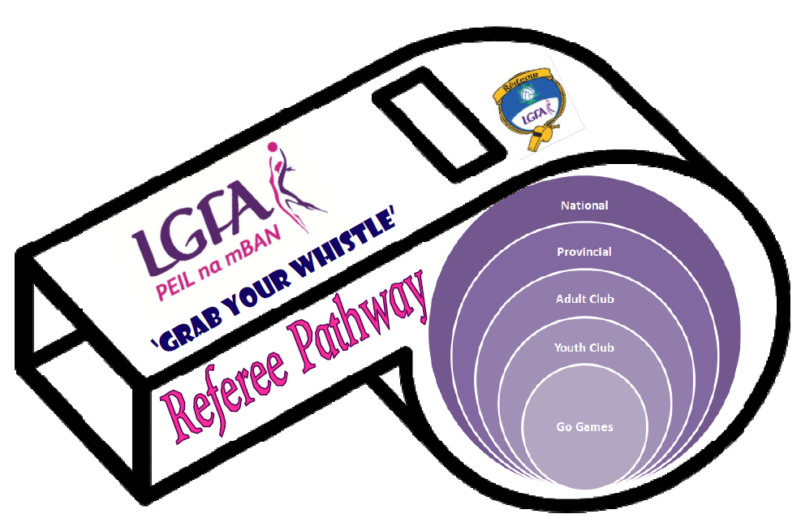

National
Level of Operation | How to Gain This Level | Pass rates
National football at adult and juvenile level | - Minimum 24 years old  - Must complete two refresher days annually | Pre-National League  - Must receive a minimum 90% in rules test and level 15.4 (14.5 for females) in the Yo-Yo Fitness Endurance test  - Must maintain assessment level minimum of Good  - Allowed one re-test two weeks from original date  Pre- Championship  - Must receive a minimum 95% in rules test and level 16.2 (15.1 for females) in the Yo-Yo Fitness test  - Must maintain assessment level minimum of V Good  - Allowed one re-test two weeks from original date
National GAA Assimilation Programme
- Must be current or past GAA National Referee
Requirements
- Full attendance at programme (2 days)
- Must receive 90% in rules test on Day 2 and level 15.4 (14.5 for females) in the Yo-Yo Test

NATIONAL

National Accelerate Programme
- Nominated by province or county
- Completion of the full programme will gain entry to the National Referee Panel
- Min. 24 years old with 5 years referee experience
Requirements
- Full attendance at programme (5 modules)
- Must receive 85% in rules test on Day 1 and level 15.2 (14.2 for females) in the Yo-Yo Test
- Must maintain assessment level minimum of Good

Provincial
Level of Operation | How to Gain This Level | Pass rates
Provincial football at adult and juvenile level | - Minimum 19 years old  - Annual refresher course to be completed every year | Start of Year  - Must receive a minimum 80% in rules test and Level 14.3 (13.4 for females) in the Yo-Yo Fitness test  - Recommended assessment level minimum of Average  Mid Year  - Must receive a minimum 85% in rules test and Level 14.5 (14.1 for females) in the Yo-Yo Fitness test  - Recommended assessment level minimum of Average

PROVINCE

Provincial Accelerate Programme
- Completion of the full programme will gain entry to the Provincial Referee Panel
- Min. 21 years old with 4 years referee experience
Requirements
- Full attendance at programme (4 modules)
- Must receive 80% in rules test on Day 1 and level 14.1 (13.3 for females) in the Yo-Yo Test
- Must maintain assessment level minimum of Average

Annual Refresher Course
Level of Operation | How to Gain This Level | Pass rates
Club football at adult and juvenile level  (Renew Annually) | - Minimum 18 years old  - Annual refresher course to be completed every year | - Must receive minimum 75% in the rules test  - Can include fitness 13.0 male and female

GAA Referee with minimum of 5 years experience may enter here
Adult Club
Level of Operation | How to Gain This Level | Pass rates
Club football at adult and juvenile level | - Minimum 18 years old  - Complete Day 1 and 2 of Adult Club Course | - Complete full course  - Online Course is available please contact office for details

Youth Club
Level of Operation | How to Gain This Level | Pass rates
Competitive Club football at juvenile level (U12-16) | - Minimum 17 years old  - Complete Day 1 and practical of Youth Club Course | - Complete full course with blitz

COUNTY

Go Games
Level of Operation | How to Gain This Level | Pass rates
Club football up to Under 12 Level (Go Games) | - Minimum 12 years old  - Complete Go Games 2 ½ hour course | - Complete full course

LGFA Grab Your Whistle Education Pathway
National |  |  |  |  |  | Access through National Accelerate/ GAA Assimilation  Pre-League & Championship Course
Province |  |  |  |  | Access through Provincial Accelerate  Annual Provincial Course
County | Go Games Programme  (For all clubs) | Go Games Course  (For all clubs) | Youth Club Course  (For all clubs) | Adult Club Course  (For all clubs)/  Annual Refresher
Club |  | Go Games Course  (Own Club) | Youth Club Course  (Own Club)
School |  | TY/AS Level Course/  Go Games Course
Third Level |  |  | Youth Club Course | Adult Club Course
Organised by | Go Games Referee Aged 12-15 | Go Games Referee Aged 15-17 | Youth Club Referee (17+) | Adult Club Referee (18+) | Provincial Referee | 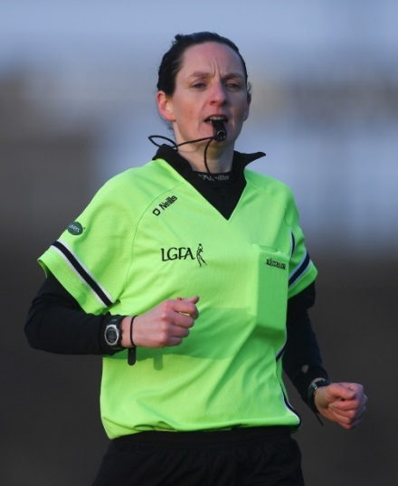  National Referee

