Player Development Programme
….Widening The Net

What is the LGFA Player Development Programme?
- An Inclusive programme for all players, focusing on a wide range of abilities
- An opportunity for players to develop individually, with different players, learn new skills, and develop the fundamental skills in a positive and safe environment
- An opportunity for all Counties to enhance their process of player development
- An opportunity for coach development and networking within a County
- Promotion of a non-competitive enjoyable environment prioritising the involvement of all players

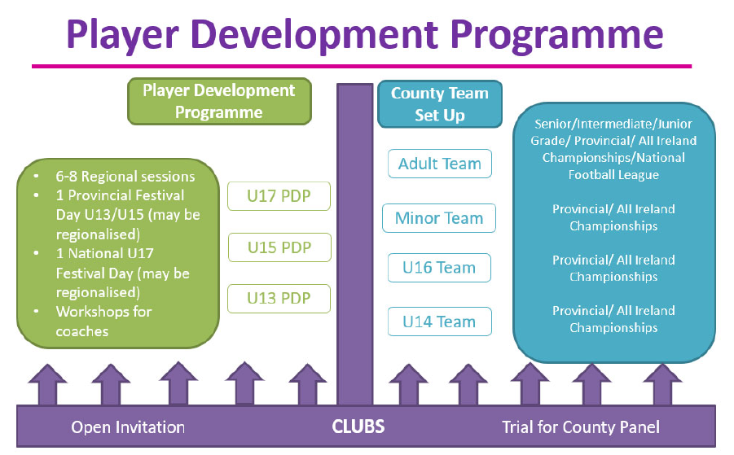

Key Info
A PDP is MAX. 8 coaching sessions to compliment club training

- No trials or selection/de-selection process – Regional programme to encourage greater participation i.e. North, South etc.
- U13 & U15 Provincial/Regional Festival Days will be entirely non-competitive
- There will be trophy, plate, cup and shield finals for U17 National Festival Day

What are the benefits of the LGFA Player Development Programme?

Format of the LGFA Player Development Programme
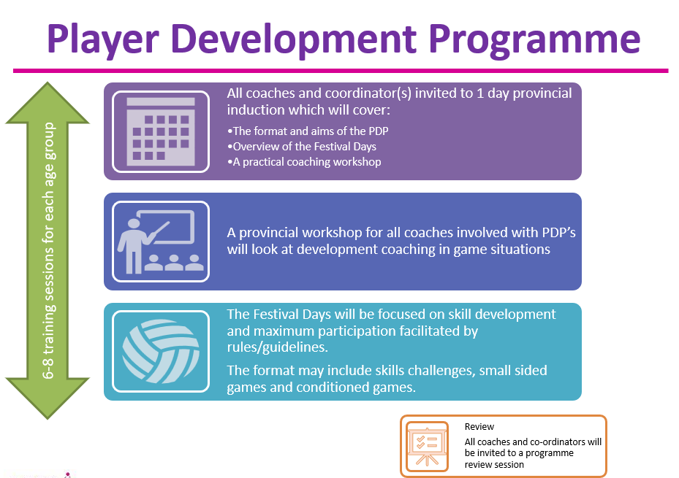

What are the Key Considerations for a County?
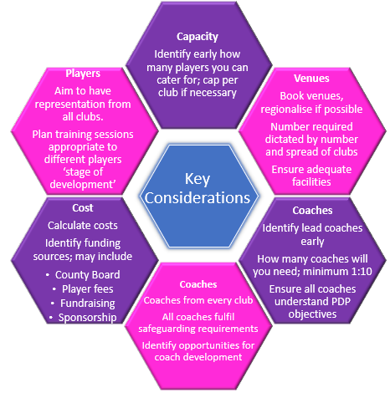

What are the Structures Associated with Each Age Group?
U13 & U15 Player Development Programme
- Regionalised County Based programme

- Number of Sessions
  - Quality over Quantity
    - Min. 6 / max 8 sessions in total over the calendar year – do not need to be concurrent
    - Need to be creative when planning content for same to ensure cater for all key areas of development every time come in contact with players

- Time of year
  - To be decided by County in order to
    - Not disrupt club fixtures, maximise club participation and not coincide with other development initiatives
    - Tie in with Provincial/Regional Player Development Programme Festival Day

- Who can attend?
  - Open invite / Inclusive based on County capacity for coach / player ratio (min 1:8/max 1:12)
  - The capacity should be set according to County resources, however should not involve a selection process i.e. trials. PDP should aim to have representation from all clubs i.e. clubs to nominate X number of player each according to number of coaches available.
  - Clubs should also be encouraged/requested to send in 1 mentor which will
    - Increase capacity
    - Be a mechanism for coach development and collaboration within the County!

- Playing Opportunities
  - At least one Provincial/Regional PDP Festival Day for each age grade will be organised by the Provincial Development Officer
  - The PDP Festival Day will be open to all players participating on the programme. No de-selecting of players permitted.
  - Festival Day will maximise number of teams on the day by utilising different game formats if required i.e. 9v9, 11v11. This will assist with player and coach development
  - The LGFA recommend a maximum of 3 other playing opportunities at U13/U15/U17 level outside what has been outlined.
A playing opportunity is defined as a non-competitive event involving 1 host County inviting no more than 3 additional Counties.
  - If a Province organises additional Festival Days on a regional basis for an age grade then this is deemed as one playing opportunity i.e. if County attends two regional festivals days organised by the Province then this means County can only host or attend a further two playing opportunities. Important how this is planned as Counties must keep within the max. 8 coaching sessions per calendar year.

What are the Structures Associated with Each Age Group?
U17 Player Development Programme

- Regionalised County Based Programme

- Sessions:
  - Min. 6 / max 8 sessions in total - do not need to be concurrent

- Time of year
  - To be decided by County in order to not disrupt club fixtures, maximise club participation and not coincide with other development initiatives

- Who can attend?
  - Open invite / Inclusive based on County capacity for coach / player ratio (min 1:8/max 1:12.)
  - The capacity should be set according to County resources, however should not involve a selection process i.e. trials and should aim to have representation from all clubs i.e. clubs to nominate X number of player each according to number of coaches available.
  - Clubs should also be encouraged/requested to send in 1 mentor which will
    - Increase capacity
    - Be a mechanism for coach development and collaboration within the County!

- Playing Opportunities
  - Competition element to remain in place. Competition is to act a ‘yardstick to measure improvement’ with focus on enhancing player development
  - National U17 Festival Day will be organised at the latter end of the Summer to include coach education element, educational talks for players and players experiencing different game formats.
  - Extra grades may be incorporated to ensure all teams play teams of their own level by end of the day
  - The LGFA recommend a maximum of 3 other playing opportunities at U13/U15/U17 level outside what has been outlined.
A playing opportunity is defined as a non-competitive event involving 1 host County inviting no more than 3 additional Counties.

What Coach Education Support will be provided to Counties?

- LGFA Player Development Programme Provincial planning and educational Workshops
  - Minimum 1 Coaching Workshop will be organised per Province

- Coaching Resources supplied

- Coach Education element to Festival Days

- Reflective coaching element to be included via Coach Observation Programme
  - Training will be provided for max. 3 Coach Observers per County

IMPORTANT TO NOTE:
- To avoid confusion – titles ‘LGFA Development Academy’ or ‘LGFA Academy Programme’ are now defunct and should not be utilised by Counties

- Counties are permitted to organise alternative localised activities to assist with their Inter County preparation at Under 14, 16 and 18 which must be separate to the LGFA Player Development Programme and named as Under 14, 16, 18.

- The LGFA recommend a maximum of 3 other playing opportunities at U13/U15/U17 level outside what has been outlined.
  - A playing opportunity is defined as a non-competitive event involving 1 host County/Province inviting no more than 3 additional Counties

Can we conduct more than 8 coaching sessions?

- The PDP should not supersede club activity hence maximum eight coaching sessions. Please note, these sessions do not need to run concurrently to ensure tie in with County games programme
- As well as the 8 coaching sessions, Counties can enter a regional/provincial Festival Day as well as opportunity to be involved in three other playing opportunities (a maximum of 12 contact days)

What is a ‘Playing Opportunity’ defined as?

- A playing opportunity is defined as a non-competitive event involving 1 host County inviting no more than 3 additional Counties

What if we are unable to plan our coaching sessions to tie in with the Regional / Provincial Festival Days arranged?

- Each County are permitted to participate in an additional three playing opportunities per age group. This will provide flexibility for games opportunities if unable to participate in the Regional/Provincial Festival Days

How will we cater for bigger numbers? What if we don’t have enough numbers?

- Prior Planning is key. Where numbers are large, the programme should be regionalised within your County
- The County programme should aim to include players from every club in the County, and every club should provide a coach for the County PDP project in turn
- The PDP has the added dimension of Coach Education and it is important to utilise this opportunity to develop coaches within the process
- If numbers are very small, liaise with the Development Team to decide whether appropriate to enter the Festival Day. This should not impact on coaching sessions

What if we have very big numbers? Do we bring everyone to each Festival Day?

- The development team in your Province will monitor the numbers attending your sessions and will plan the regional or Provincial days accordingly to ensure everyone gets opportunity to be involved
- There should be no selection or de-selection of players unless players commitment to the programme is not what it should be i.e. players only attends 20% of total sessions
- The three playing opportunities will also allow Counties to be flexible in ensuring every player gets meaningful playing time

With the big numbers, will this mean reduced playing time at the Festival days?

- No we aim to provide at least 80 minutes football for each team involved. Providing players with as much playing time will be a priority when planning the festival days

Can we conduct any other U13/15/17 activity outside PDP Project?

- No, the only County activity permitted and sanctioned is the PDP for these age groups
- Development activities organised for age groups lower than U13 i.e. U11/U12 are no longer permitted and this time should be devoted to more club blitzes etc. to provide more football for all players

What sanctions are in place if a County breach the PDP Project guidelines? What is a breach?

- A sanction of €500 per breach will apply to each County e.g. a County conducts more than 8 coaching sessions at this age group for the PDP Project

If a County wants to organise additional playing opportunities, how do we go about this?

- A County may host a maximum of three Counties for a PDP Festival Day
- Email William Harmon – william.harmon@lgfa.ie in advance of the planned festival day to get permission

Are Provinces permitted to organise development leagues for U13, 15 and U17?

- No, the only game opportunities are what are outlined via the PDP.
- Provinces may organise more than one Provincial/Regional Festival Day but this would be deemed as a playing opportunity for the counties that participate i.e. if County attends two regional festivals days organised by the Province then this means County can only host or attend a further two playing opportunities. Important how this is planned as Counties must keep within the max. 8 coaching sessions per calendar year.

What if we want to commence preparation early for our U14/16/U18 County Teams?

- The PDP project does not impinge on County Team Preparation
- If Counties want to hold trials, select players, organise subsequent training activities and challenge games etc. for these county age grades (Under 14,16,18) then this is permitted once the promotion of same is separate to PDP Project and named at those age grades.
- The titles ‘Academy’ or ‘Development Squad’ are no longer permitted so important the above activity reflects the purpose of same i.e. when requesting permission for challenge games, it must be requested as U14/U16/U18 Inter County Preparation
- No alternative U13/15/U17 County activity is permitted outside PDP

What if a County does not want to participate in the PDP Project?

- It is a Counties decision whether or not they organise a County PDP. Counties may run a PDP for selected age groups i.e. U13 only
- If Counties organise County Team Preparation and no Player Development Programme, then the title of the above must still be in keeping with the purpose of the exercise i.e. U14/U16/U18 County Team Preparation
- The title of the activity is important to ensure that all stakeholders (players, coaches, clubs etc) have full understanding of the objective of the activity

