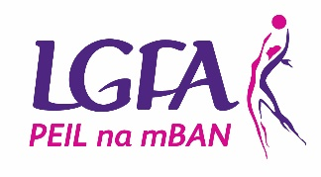
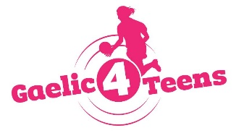
GAELIC4TEENS
2021 Application form

To register your Club’s interest and apply for the 2021 Gaelic4Teens programme, please complete this application form and return it to Clare Conlon by email developmentsupport@lgfa.ie by Friday 20th November 2020.

Please Note – All sections must be completed or the application will not be accepted
Club Name: ___________________________________________________________
County: ___________________________________________________________
Club contact for this application: ___________________________________________________________
Phone: (Home): ___________________ (Mobile): _____________________
Email: ___________________________________________________________
How long is your Ladies Football Club in existence? ___________________________________________

MEMBERSHIP FIGURES:
Age Group | Total number of registered members | Number of mentors currently involved with the team(s)
Under 8
Under 10
Under 12
Under 14
Under 16
Under 17
Under 18
Adult

CATCHMENT SCHOOL INFORMATION (fill in for both programmes)

Name of POST PRIMARY Schools in your area | Mixed/All Girls | Number of Girls aged 13 – 17 years | Catchment Clubs

REASONS TO BE SELECTED:
Please give the top 3 reasons why your Club should be selected to host 2021 Gaelic4Teens Programme…

RESOURCES
Please provide list of coaches that will be participating in this programme and indicate what age group they are involved with in the club

Name of  G4T Programme Co-Ordinator | Name of coaches  (where applicable to your club)
U13

U14

U15

U16

U17

KEY DATES:
Online Induction Evening
- If selected for the programme, all club G4T Programme Co-ordinators (other personnel welcome also) must attend an online induction evening prior to the commencement of the programme
- Online Induction Dates will take place on Thursday 14th January at 7.30pm.

Gaelic4Teens Programme Dates
- All coordinators and coaches involved in the programme must attend all dates associated with programme
Venue One - Cavan | Venue Two - Limerick | Venue Three – Dublin
Day One Sat 13th Feb ‘21  Day Two Sat 27th Mar ‘21 | Day One Sat 13th Feb ‘21  Day Two Sat 27th Mar ‘21 | Day One Sun 14th Feb ‘21  Day Two Sun 28th Mar ‘21
NOTE - The above delivery format and dates may change

G4T Festival Day format and dates will be dependent on Government Guidelines

Please tick which dates suit your club. Please note, we can only accommodate 10 clubs per venue but we will endeavour to facilitate where possible:

Venue One Venue Two Venue Three

I confirm that:
- All information supplied in this application form is accurate
- I have read the G4T Overview Booklet in full and will fully comply with all terms and conditions associated with the roll out of the programme
- I understand all dates associated with the programme and understand mandatory attendance of club at same

Signed: _________________________________ Date: _______________________________

Please submit by post to Clare Conlon, Ladies Gaelic Football Association, Croke Park, Dublin 3 or email Clare @ developmentsupport@lgfa.ie Tel:01 8363156

Please note that any applications received after the closing date (Monday 16th Nov 2020) will not be considered for the Gaelic4Teens programme this year.

