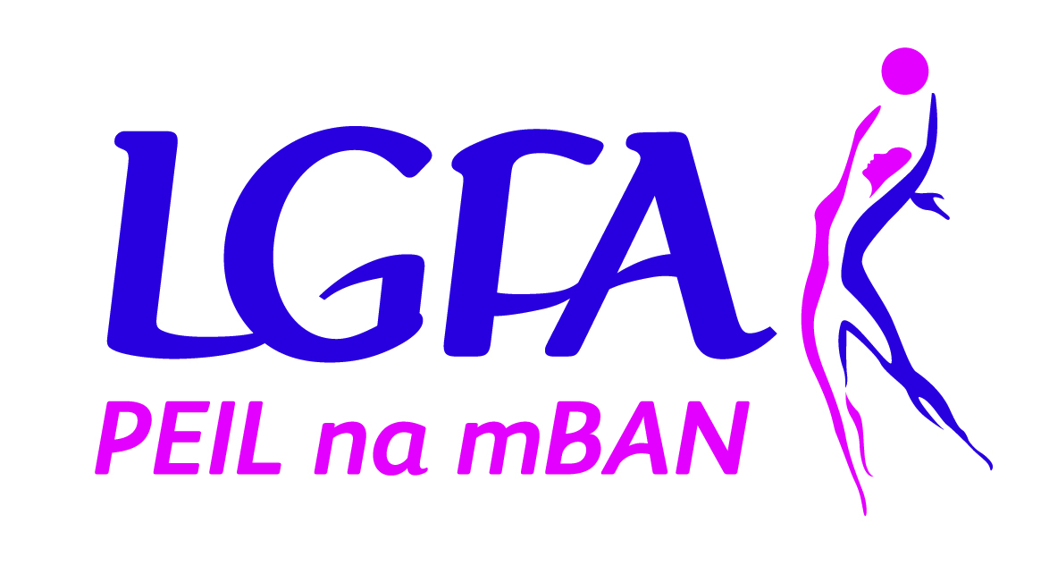

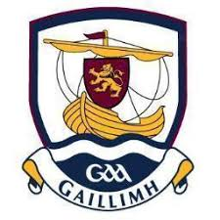

Galway LGFA
Senior Inter County
Manager

Role Description
Galway LGFA Senior Inter County Manager Role Description.

Job Title: Galway Ladies Senior Inter County Manager
Minimum Experience required:
- Be a member of the Ladies Gaelic Football Association and have a general knowledge of how Ladies Gaelic Football procedures and policies operate
- Demonstrate at least 3 years of a proven track record in management of club and/or county team
- An ability to demonstrate / organise a high standard of coaching (At least Level 1 Coaching Certificate in LGFA/GAA is preferable)
- Has an understanding and will work within the Guidelines of the LGFA and the Code of Ethics and Good Practice for Young Players
- Be Garda Vetted.

Skills and Attributes of an LGFA Mentor:

- Demonstrate good ability to plan
- Have suitable player management and organisational skills
- Have exceptional leadership qualities
- Be highly motivated and driven to succeed by maintaining high standards of professionalism at all times
- Have the ability to work as part of a team and work competently with County Board officers, club mentors and when required, the media.
- Be committed
- Ability to create a positive environment for all players to develop to the best of their ability
- Have good communication skills and display good listening skills and communicate clearly and concisely with County Board members, Clubs and players
- To be approachable and encourage players to express their thoughts when required
- Have the ability to evaluate and provide quality feedback to facilitate learning and development of players

Duties and Responsibilities:
- Ensure all of the management team/background team including the Manager are registered members of the Association and are successfully vetted/Access NI checked or as applicable in other jurisdictions
- Responsible for coordination of activities for the Galway Ladies Senior Team
- Provide strong leadership and encourage a supportive team environment with coaching, backroom team and players. Your Backroom team must include at least one female liaison person.
- Plan, prepare, deliver and evaluate quality and appropriate coaching
- Develop knowledge and understanding of fitness, injury, sports psychology, nutrition and sports science programme/activities to improve and develop the players
- Ensure all relevant personnel are aware of the aims of each session, rationale of every endeavour etc.
- Value input of all helpers, assistant coaches and players at all times
- Be willing to delegate jobs and ensure the assigned person fully understands their tasks
- Develop positive working relationship with the County Board and ensure they are aware of all activities and encourage strong links and communication between each of you throughout the season.
- Ensure that all associated costs are within agreed budgets for the season and that a system is put in place where items such as i.e. physio, equipment, team gear, training facilities etc. are required are forwarded to the County Board for approval first and secondly for the board to purchase and pay for same.
- Develop relationships with clubs to assist prevention of club and county divisions and ensure playing opportunities for club and county players. Abide by and promote sound ethics and county policy, child protection, fair play and equal opportunities to all members.
- Committed to ongoing continued professional development by attending LGFA coach education courses and any in-service training that is organised by the County Board.
- Take responsibility for ensuring that all equipment provided to the manager is the responsibility of the manger and that they are kept in good condition throughout the season.
- Be aware of and promote the LGFA codes of conduct for coaches, players and parents at all times.
- Ensure rules of the Association are abided by all
- Wear the official County Team attire when representing the County on and off the pitch
- Co-operate with any media pre and post games as requested by the County Board, Provincial Councils and the National body of the Ladies Gaelic Football Association and communicate consistent and effective media messages at all times
- Co-operate and attend any events organised for the promotion and marketing of ladies football at County, Provincial and National level.
- Be a role model and ambassador gaining the respect and trust of the people you come in contact with

All completed application forms must be returned via post or email to the county secretary no later than 5pm Tuesday 19th January 2021. Interviews will take place shortly thereafter.

Secretary’s email address:- secretary.galway@lgfa.ie

Or post to:

Geraldine Heverin
Ballyedmond,
Clonberne
Co. Galway
H53E036

Galway Ladies Gaelic Football Association
Senior Inter County Management Application Form
Senior Inter County Manager
Position applied for:

- Personal Details (Please use capital letters):
Name:
Address:
Email:
Phone:
Mobile:
Club:

- Code of Ethics & Good Practice for Young Players
Garda Vetting:
Please attach a copy of your Garda Vetting Certificate to application, if you have not yet applied to be Garda vetted please download a form from www.ladiesgaelic.ie and forward onto Paula Prunty, Croke Park, Dublin 3 ASAP

- Coaching qualifications (Please tick relevant box):
LGFA FUNdamentals Coaching Course |  |  |  | LGFA Level 1 Coaching Course
Yes |  | No |  | Yes |  | No
Date: |  |  |  | Date:
Please list the name of other coaching courses you have completed which is relevant to your application:

- Management Experience:
List previous playing experience (applicable to club / county):
List previous managerial roles / experience (applicable to club / county):
- Playing Experience

- Proposed Management Team:
(Applicants must specify their full management team prior to interview stage)
Position | Name | Club | Garda Vetted
 |  |  | Yes | No
Team Selector
Team Selector
Female Selector
Team Administrator
Medic / First Aid / Physio
Fitness Coach
Other (state role)
- References:
Please supply the name, address and contact details of two people whom the Galway LGFA can contact that from their personal knowledge are willing to endorse your application.
Referee (1): | Referee (2):
Name: | Name:
Address: | Address:
Address: | Address:
Email: | Email:
Number: | Number:
Position: | Position:
- General Information:
a) Do you agree to abide by the guidelines of Code of Ethics & Good Practice for Young Children | Yes | No
b) Do you agree to abide by the rules of the Ladies Gaelic Football Association and the Galway Ladies Gaelic Football Association? | Yes | No
c) Do you agree to abide by the Galway Code of Best Practice for Inter County Management | Yes | No
- Any other relevant information:
List any additional qualifications, skills or experiences that may be relevant to position applied for & attach certificates of qualifications:

- Budget
Please provide a draft annual budget, upon agreement with management team, as to the expected running costs of your team (costs should include expectations for professional services e.g. physio, strength & conditioning, professional services, team building, expenses). Note – transport, gear and equipment will be provided by Galway Ladies County Board for all teams.

- Signature: ________________________________ Date: / / /

