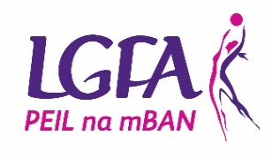
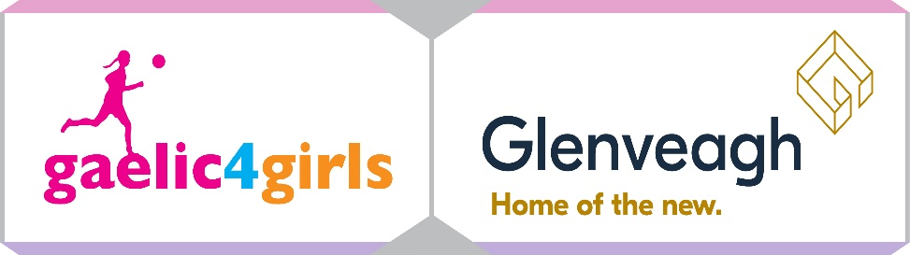
Ulster G4G Application form

To register your Club’s interest and apply for the 2022 Gaelic4Girls programme, please complete this application form and return to Ulster Development Officer Ciaran Murtagh by email to Ciaran.murtagh.ulster@gaa.ie by 15th November 2021.

Please Note – All sections must be completed or the application will not be accepted

Club Name: ______________________________________________
County: ______________________________________________
Club contact for this application: _____________________________________________
Phone: (Home): ___________ (Mobile): _____________________
Email: ________________________________
How long is your Ladies Football Club in existence? _______________________________
MEMBERSHIP FIGURES:
Age Group | Total number of registered members | Number of mentors currently involved with the team(s)
Under 8
Under 10
Under 12
Under 15
Under 16
Under 17
Under 18
Adult
Non Players
Gaelic4Mothers & Others

SCHOOL INFORMATION (fill in for both programmes)
Name of PRIMARY Schools in your area | Mixed/All Girls | Number of Girls aged 8 – 12 years

REASONS TO BE SELECTED:
Please give the top 3 reasons why your Club should be selected to host…
2022 Gaelic4Girls Programme

EVIDENCE
Please provide evidence to indicate that your Club has the sufficient resources to host the Gaelic4Girls Programme
 | Co-Ordinator | Coaches  (Min 3 per age group) | Facilities | Equipment
Gaelic4Girls programme

I confirm that:
- All information supplied in this application form is accurate
- I have read the G4G information sheet in full and will fully comply with all terms and conditions associated with the roll out of the programme(s)

Signed:__________________ Date: ____________________

Please note that any applications received after the closing date (15th November 2021) will not be considered for the Gaelic4Girls programme this year.

