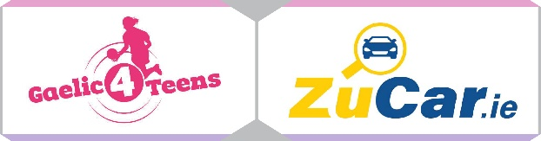
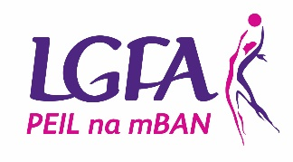

GAELIC4TEENS
2022 Application form

To register your Club’s interest and apply for the 2022 Gaelic4Teens programme, please complete this application form and return it via email to developmentsupport@lgfa.ie by Friday 19th November 2021.

Please Note – All sections must be completed, or the application will not be accepted
Club Name:

County:

Club contact for this application:

Phone: (Home): (Mobile):

Email:

How long is your Ladies Football Club in existence?
MEMBERSHIP FIGURES:
Age Group | Total number of registered members  (Where applicable) | Number of mentors currently involved with the team(s)  (Where applicable)
Under 8
Under 10
Under 12
Under 14
Under 16
Under 17
Under 18
Adult

CATCHMENT SCHOOL INFORMATION (fill in for both programmes)

Name of POST PRIMARY Schools in your area | Mixed/All Girls | Number of Girls aged 13 – 17 years | Catchment Clubs

REASONS TO BE SELECTED:
Please provide 3 reasons why your Club should be selected to host 2022 Gaelic4Teens Programme…

RESOURCES
Please provide list of coaches that will be participating in this programme and indicate what age group they are involved with in the club

Name of  G4T Programme Co-Ordinator | Name of coaches  (Where applicable to your club)
U13

U14

U15

U16

U17 /18

KEY DATES:
PHASE ONE – MAKING SENSE OF THE THEORY
JANUARY 2022
Format | Date | Topic | Target Group
Virtual Classroom (Live Webinar) | Monday 24th January 9pm | Induction | Club Executive and coaches

FEBRUARY 2022
Virtual Classroom (Live Webinar) | Monday 14th February 8.30pm | Coaching Approach and Behaviours  Receive Sessions 1 to 3 | Coaches
Virtual Classroom (Live Webinar) | Monday 21st February 8.30pm | Teaching Games for Understanding  Receive Sessions 4 to 6 | Coaches

MARCH 2022
Virtual Classroom  (Live Webinar) | Monday 7th March 8.30pm | Physical Considerations | Coaches
Virtual Classroom (Live Webinar) | Monday 21st March 8.30pm | Nutrition/Hydration | Coaches, Players and Parents
APRIL 2022
Virtual Classroom (Live Webinar) | Monday 4th April 8.30pm | Lifestyle Balance | Coaches, Players and Parents
Virtual Classroom (Live Webinar) | Monday 11th April 8.30pm | Coaching within the Rules  Promote online course as a refresher following same | Coaches

PHASE TWO – PUTTING THE THEORY INTO PRACTICE
APRIL/MAY (Date TBC) NATIONAL GAELIC4TEENS FESTIVAL DAY
MAY 2022
Virtual Classroom (Live Webinar)  OPTIONAL | Monday 9th May 7pm | Coach Observer Training Session 1 | Coaches interested in this area
Virtual Classroom (Live Webinar)  OPTIONAL | Monday 23rd May 7pm | Coach Observer Training Session 2 | Coaches interested in this area

JUNE/JULY 2022
JUNE - JULY CLUB VISITS
PHASE THREE – MAKING IT SUSTAINABLE
SEPTEMBER 2022
Virtual Classroom (Live Webinar) | Wednesday 12th September  8.30pm | Creating Positive Club Coaching Climate Part One | Executive and coaches
Virtual Classroom (Live Webinar) | Wednesday 26th September  8.30pm | Creating Positive Club Coaching Climate Part Two | Executive and coaches
OCTOBER 2022
Virtual Classroom (Live Webinar) | Monday 10th October 8.30pm | Review or Follow Up | Coaches

I confirm that:
- All information supplied in this application form is accurate
- I have read the G4T Overview Booklet in full and will fully comply with all terms and conditions associated with the roll out of the programme
- I understand all dates associated with the programme and understand mandatory attendance of club at same

Signed: Date:

This can be digital signature

Please submit via email to developmentsupport@lgfa.ie by Friday 19th November 2021.

Please note that any applications received after the closing date will not be considered for the Gaelic4Teens programme this year.

