Cavan LGFA

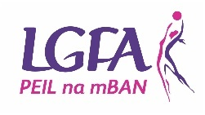
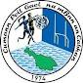

Applications are invited from suitably qualified persons for the following posts;

- Strength and Conditioning

- Physio

- Nutritionist

This position is on a Part Time bases for all County Teams.

The latest date for the receipt of completed CV and Particulars
is 5.00 p.m. on Friday 12th August 2022. Completed forms should be email to secretary.Cavan@lgfa.ie

Cavan LGFA is an equal opportunities employer.

Jonathan Kane
Chairperson Cavan LGFA

