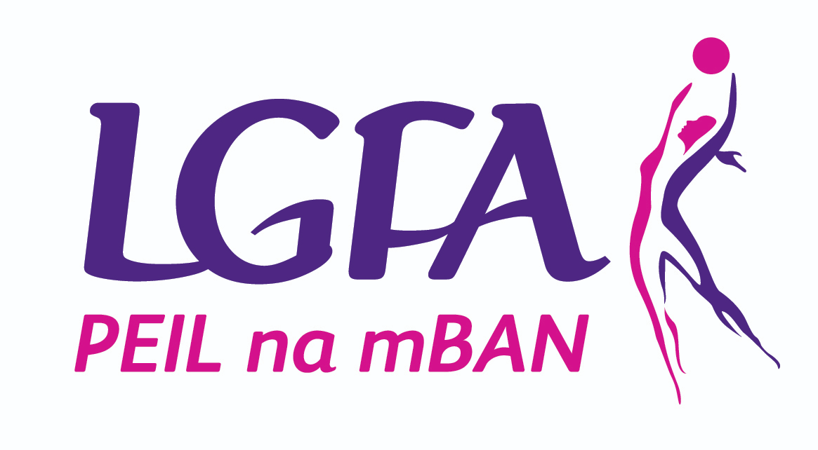

LGFA Level 2 Coaching Course

Application Form

By completing this Application Form, you agree that you qualify under the conditions outlined below for the LGFA Level 2 Coaching Course.

Application Form

Name
Address
Mobile |  | Date of Birth
Email
Club |  | County
Team Currently Coaching
LGFA Level 1 Coaching Course Details
Coaching Experience (years)
Referee from Club/County |  | Tel. No.
Details of other coaching qualifications, title and date achieved (if any):

Requirements to participate in the LGFA Level 2 Coaching Programme are as follows:

Participants must:

- Have completed the LGFA Level 1 Coaching Programme (GAA Level 1 cannot be accepted)
- Be 18+ years old
- Have minimum of 5 years coaching experience
- Be actively coaching in either of the following areas:
  - Adult Club Football
  - Underage County Player Development Programme
  - Underage or Adult Inter County Teams
- Be available to attend ALL 4 days of the programme for full duration

Please indicate in the vacant boxes course you’re applying for
Course One | Course Two
Venue: Mallow Region, Cork | Venue: Cavan Region
Day 1 – Saturday 15th July | Day 1 – Saturday 15th July
Day 2 – Sunday 16th July | Day 2 – Sunday 16th July
Day 3 – Saturday 26th August | Day 3 – Saturday 19th August
Day 4 – Saturday 23rd September | Day 4 – Saturday 9th September

- Time 10 – 4pm (All Four Days)
- Cost 120 Euro - To be paid in full prior to the course.
- Closing Date to apply: Friday 9th June 2023

Please note: All places (Max. 16 per course) will be subject to screening by the LGFA

Participant Name (Please Print)

Signed

Date

Payment details

Cheque: (made payable to Ladies Gaelic Football Association)

Credit Card: visa debit

Card Number:

Expiry Date:

Please return this form along with FULL payment to:

Postal: Margaret McCorry, Development Support Administrator, LGFA, Croke Park, Dublin 3

Email: developmentsupport@lgfa.ie

By Friday 9th June 2023

Please note:

- Payment will not be processed until participants selected confirm participation

- NO refunds available from point coaches confirm participation in the programme

